

Functionalities of PO NIMT Web Application

Document N.: Functionalities of PO NIMT web application.

Revision: 1.0

Date: 30/09/2021

For further information please contact:

[support@projectobjects.com](mailto:support@projectobjects.com)  
[www.projectobjects.com](http://www.projectobjects.com)

© 2019 Project Objects Ltd

Table of contents

1. Introduction & Workflow of Credit Submission 2

2. Introduction & Workflow of Project 9

**3.** **Functionalities of Change Management…………………………………………………………………………………..15**

**4. Functionalities of Currency rate conversion……………………………………………………………………………..19**

**5. Functionalities of Asset unit and Process Unit………………………………………………………………………….23**

**6. Functionalities of User and Group Management System………………………………………………………….26**

**7. Functionalities of tab creation in credit summary…………………………………………………………………….31**

# Introduction & wORKFLOW OF CREDIT SUBMISSION.

In credit submission section is the given proposal of budget request to regarding development of particular project and In this we will have to required budget request approval process from multiple types owner. Here now we start the workflow of credit submission steps.

1. In Menu Credits click on Credits Submission. 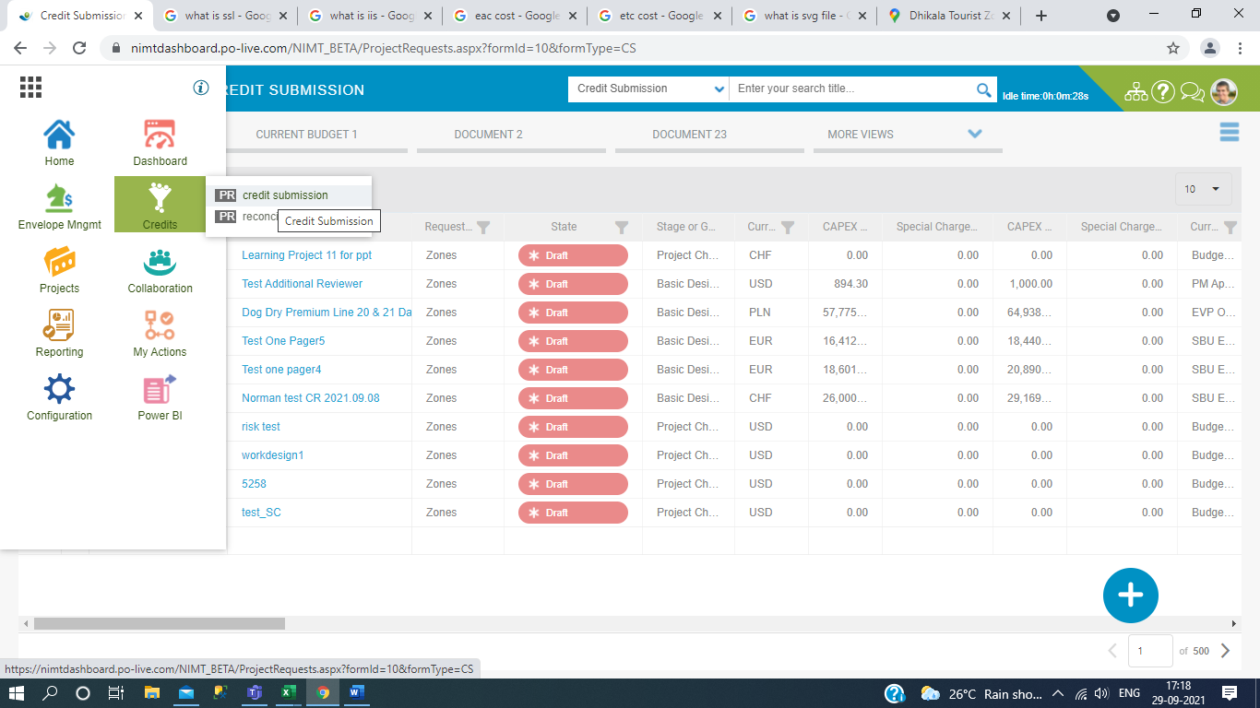
2. Then Click on Add Button. 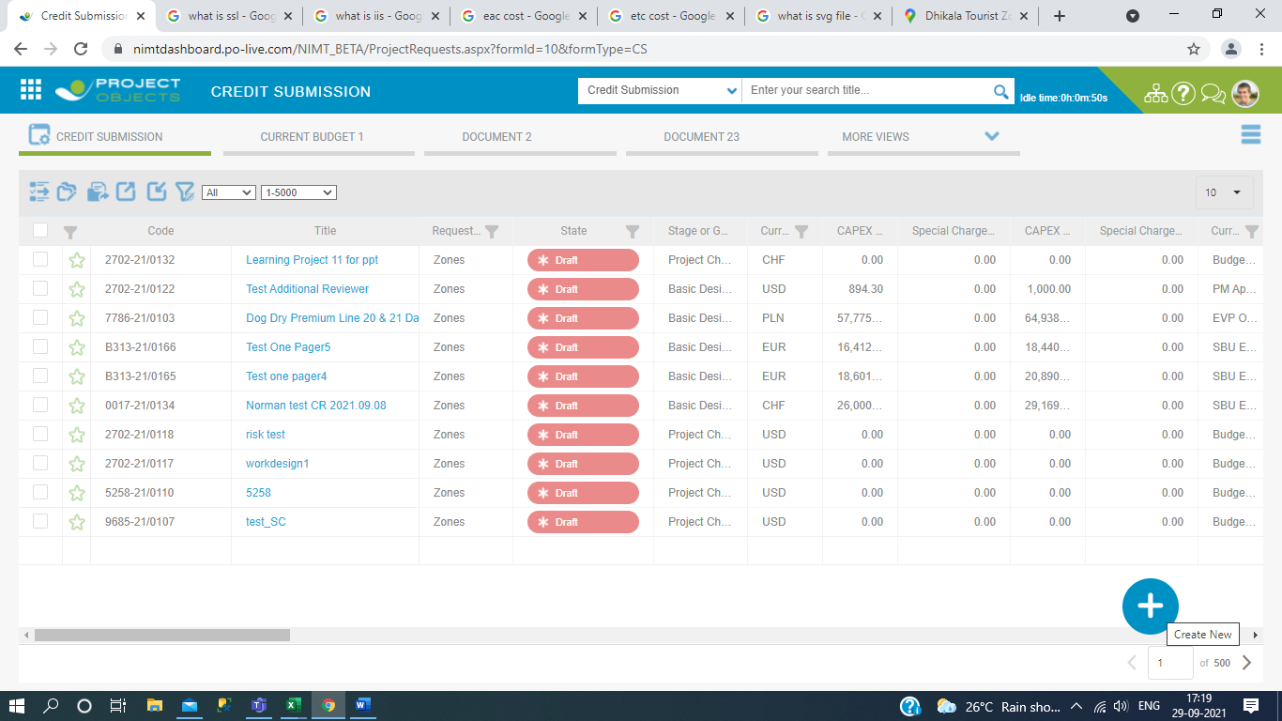
3. Then give the credit name and select the CR HO Heredia. 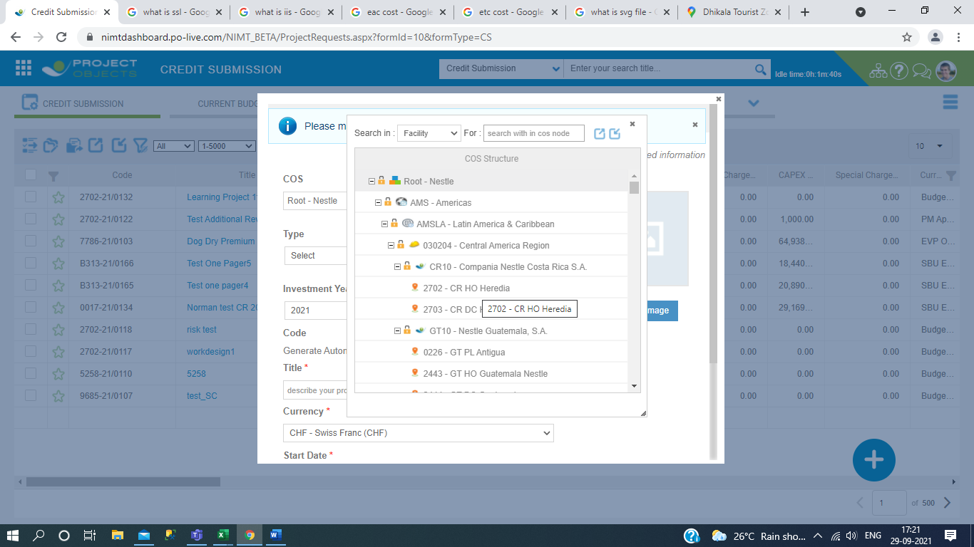
4. Fill the Title Name, take currency name CHF and take minimum one year of project and take start date and finish date and then click on save and edit icon. 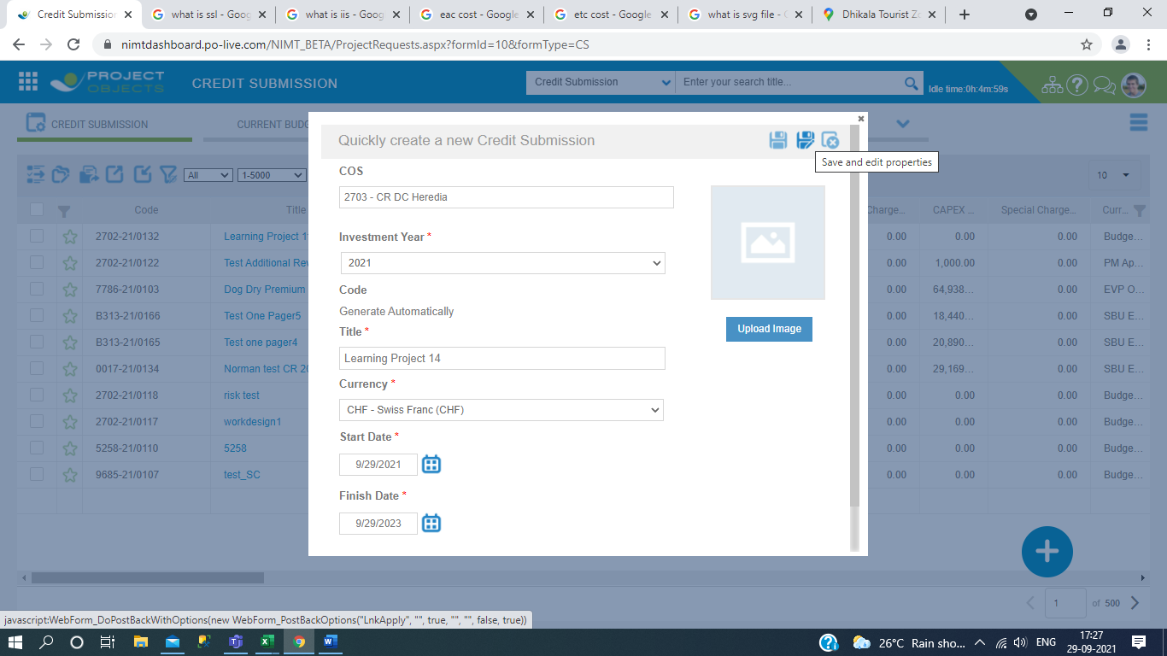
5. Then we will proceed the Detail section and filled all the validate mark and click on apply button icon and fill the investment area and fill the SBU and Product Category and then save. 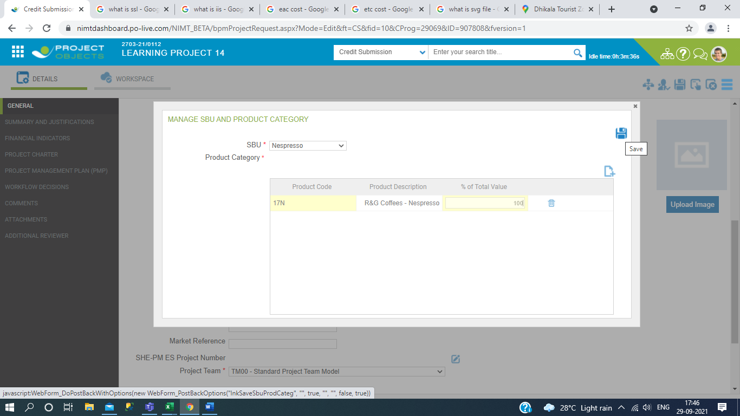
6. After this, filled all details of details section and click on apply icon button. 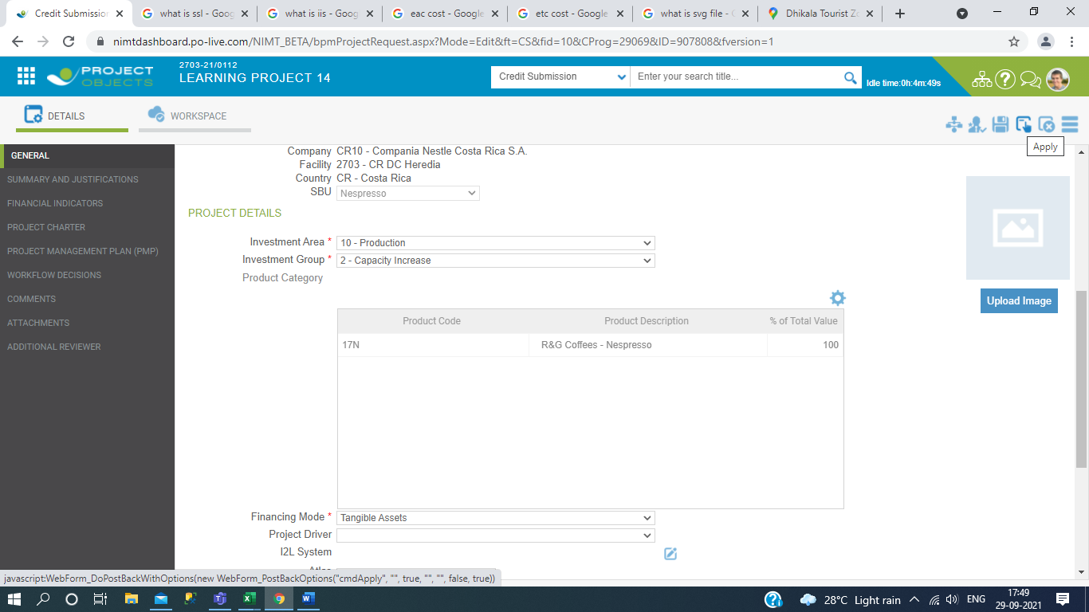
7. Then after we go to click on workspace and select cost planning section and define the Original budget.

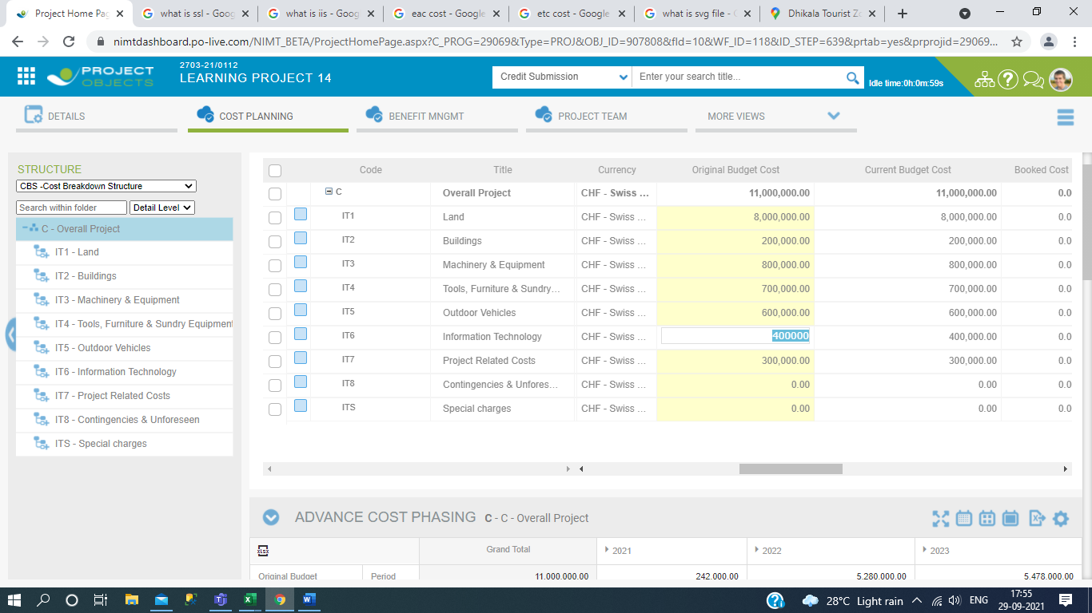

1. Then we start the Releasing approval process for this we go to follow the rule workflow details. First the we select configuration in menu section. 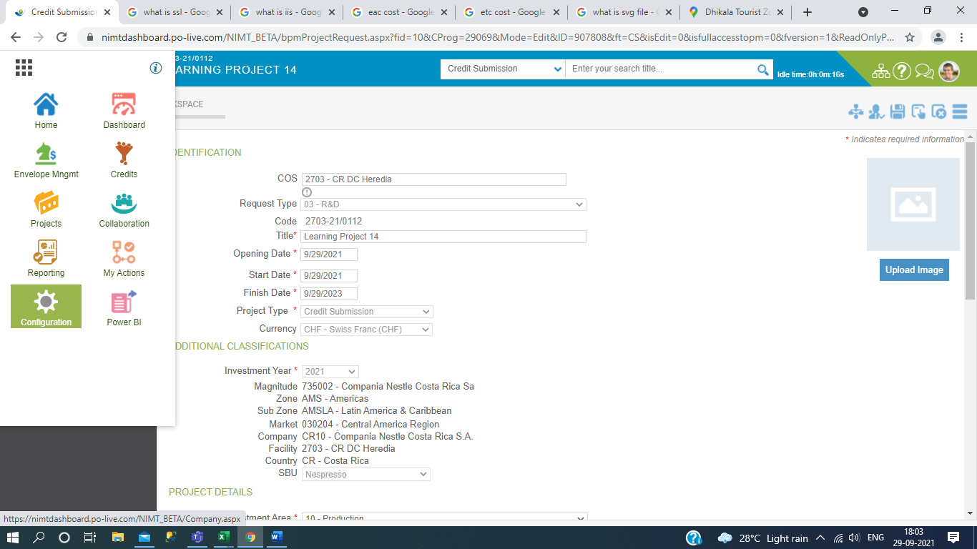

Then Select the Workflows Designer in Business Process Management.

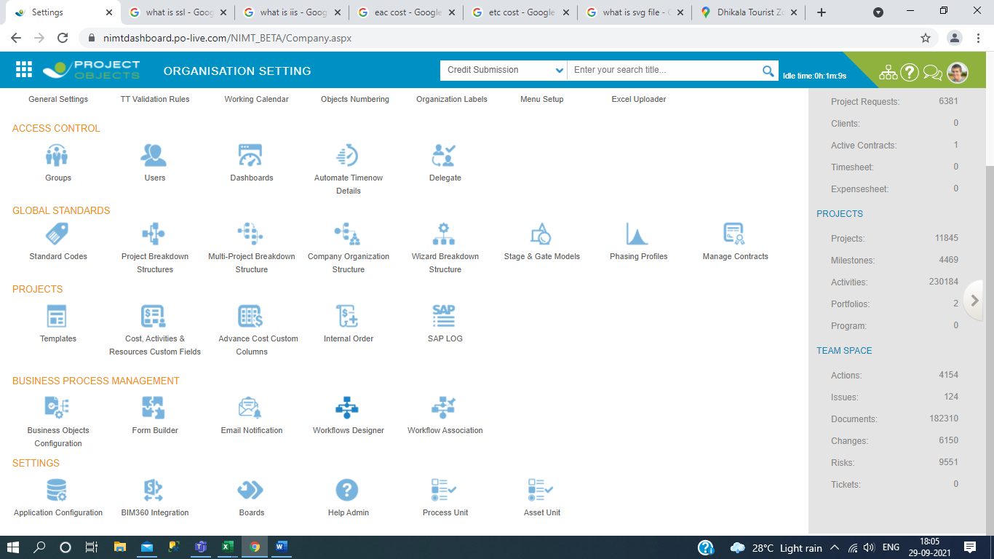

Then select the Project in Workflow Type dropdown.

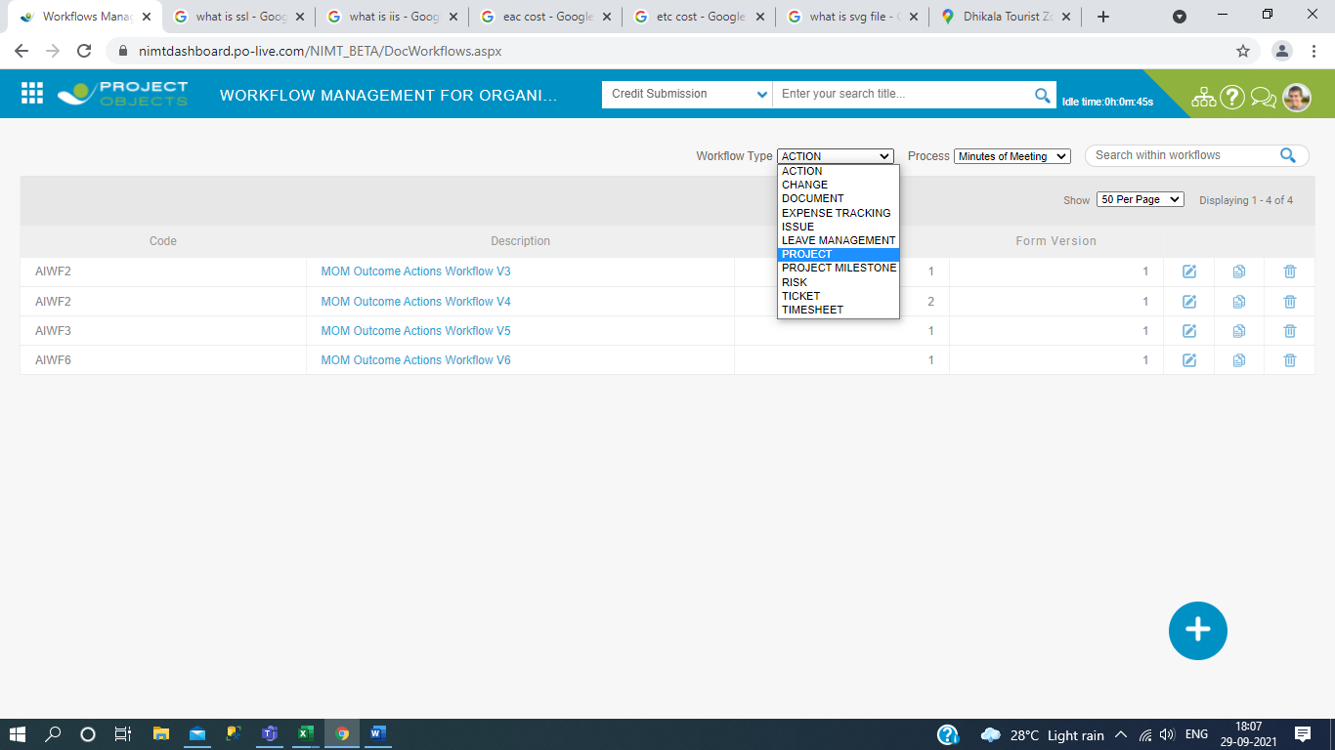

How do we know the Workflow version? First we go to credit submission and see your Title Name and regarding also seen the Progress column and click on round circle then we see the workflow version.

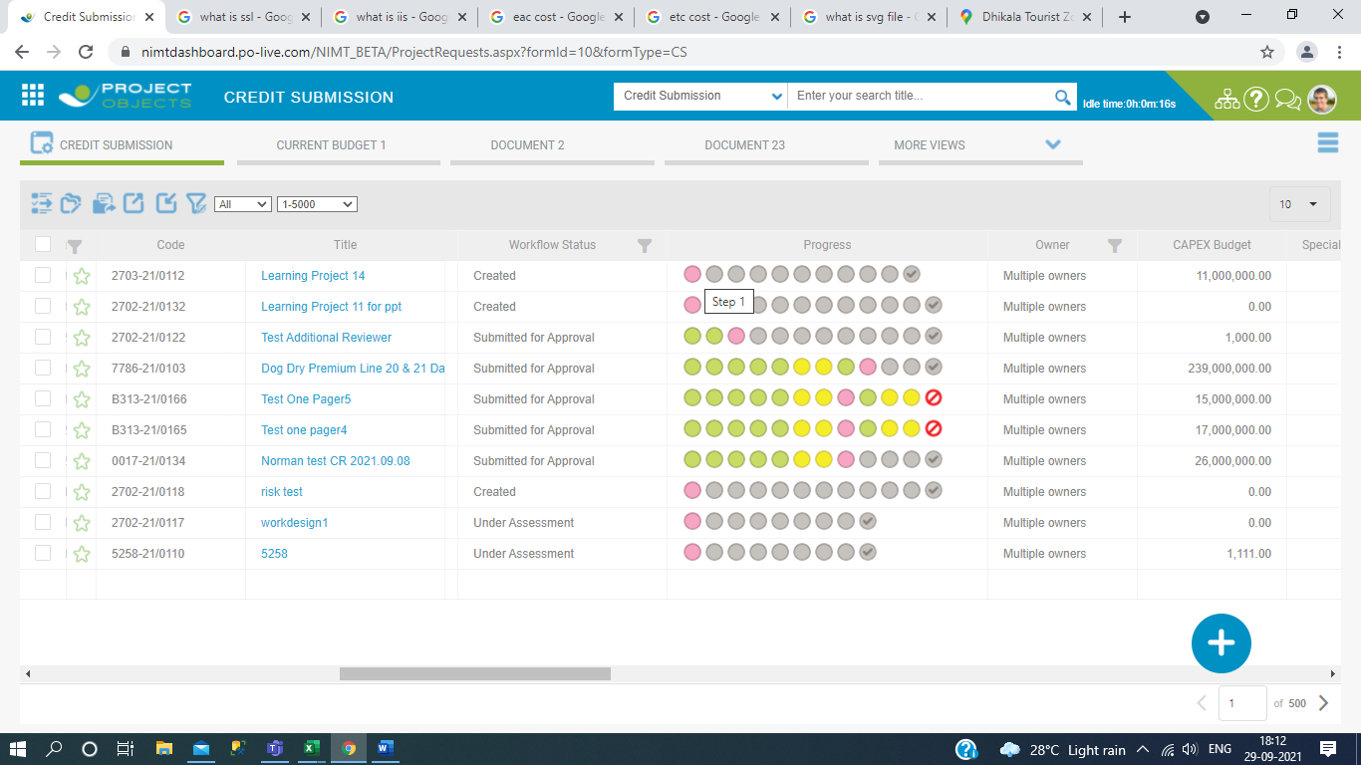

And after click you will see the Release Status.

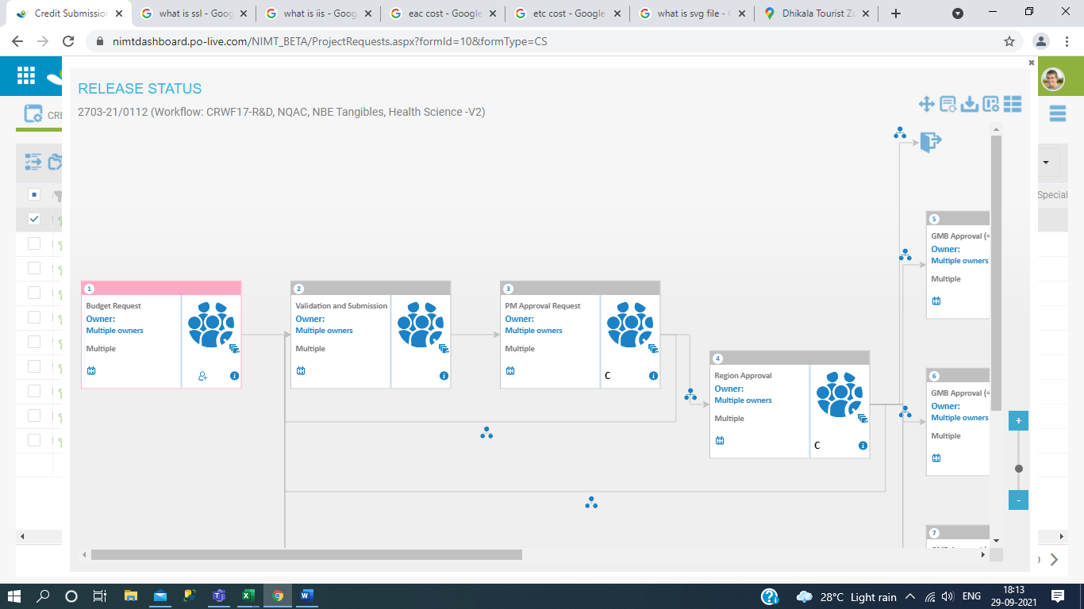

After we know the workflow version then we select the workflow in Workflow Designer open in new tab in browser.

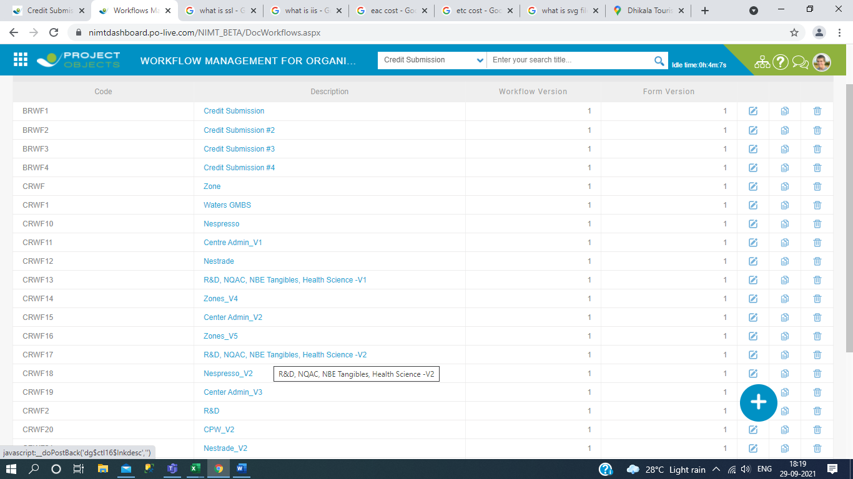

1. Then after click open the page and select or click on the workflow details and see all the condition steps and apply the conditions and submit the release process after seeing the workflow steps condition. 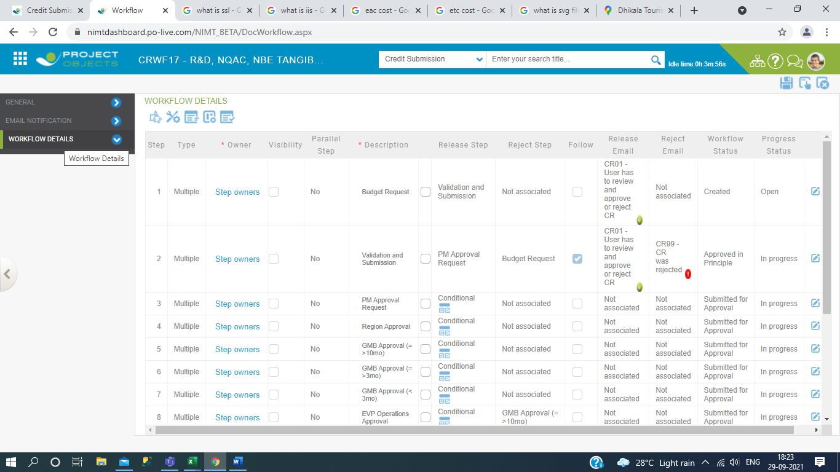
2. Then which one you create the Title name open it and then go to the detail section and click on workflow management icon.

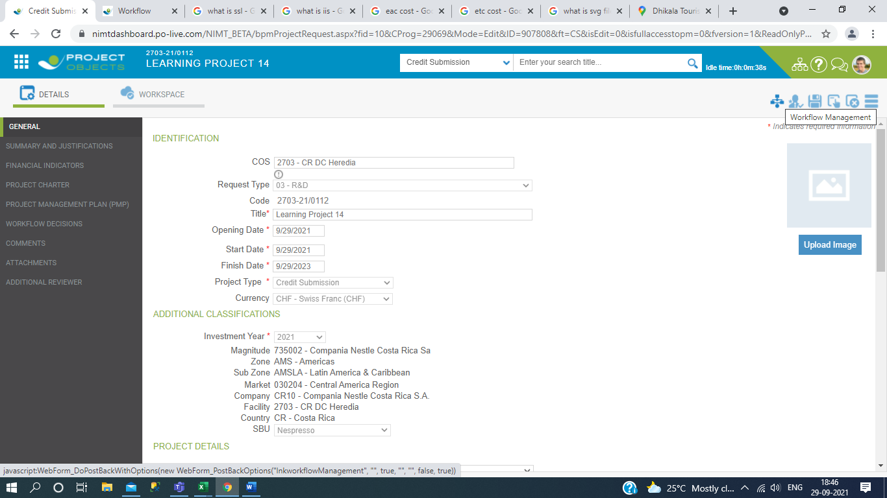

1. Then open workflow management and click on Release Button.

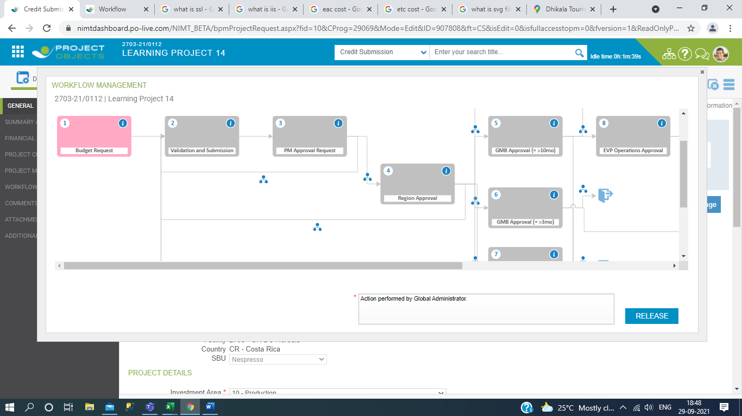

1. Before release step go through click on workflow decisions in Detail Section and submit the approve decisions and then click on apply button.

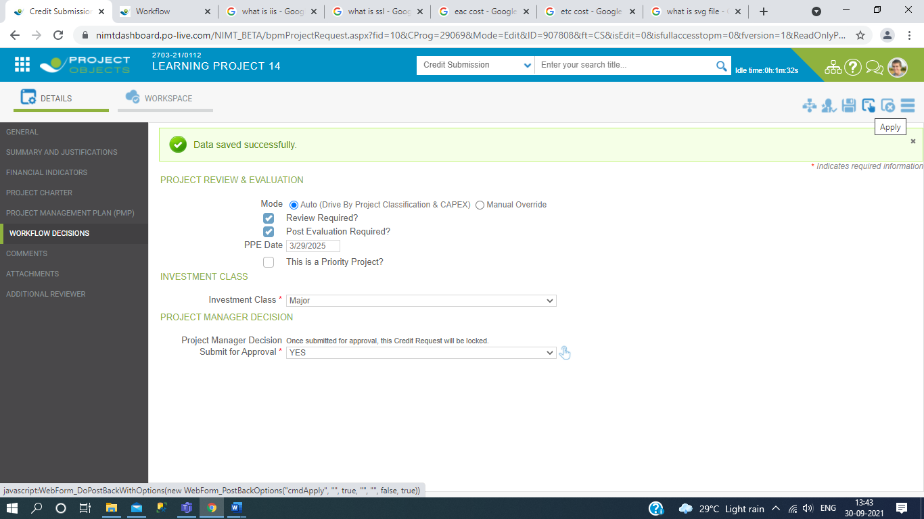

1. Then After we Release all the request approval and matched with condition steps from workflow designer and which release process steps passes away then release status will be shown in green.

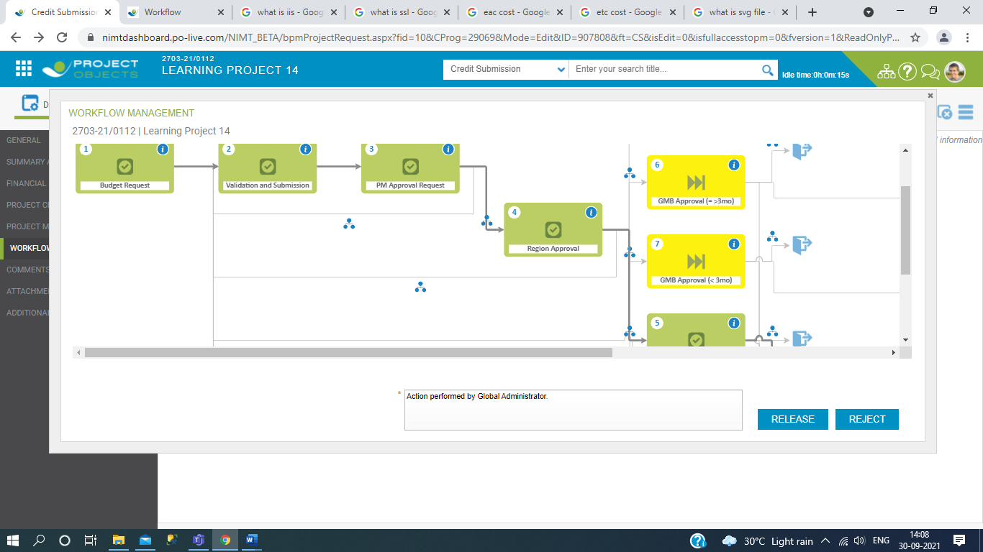

1. Then after Releasing submit request approval process this is visible in Project Section and we will proceed the Project in Menu click.

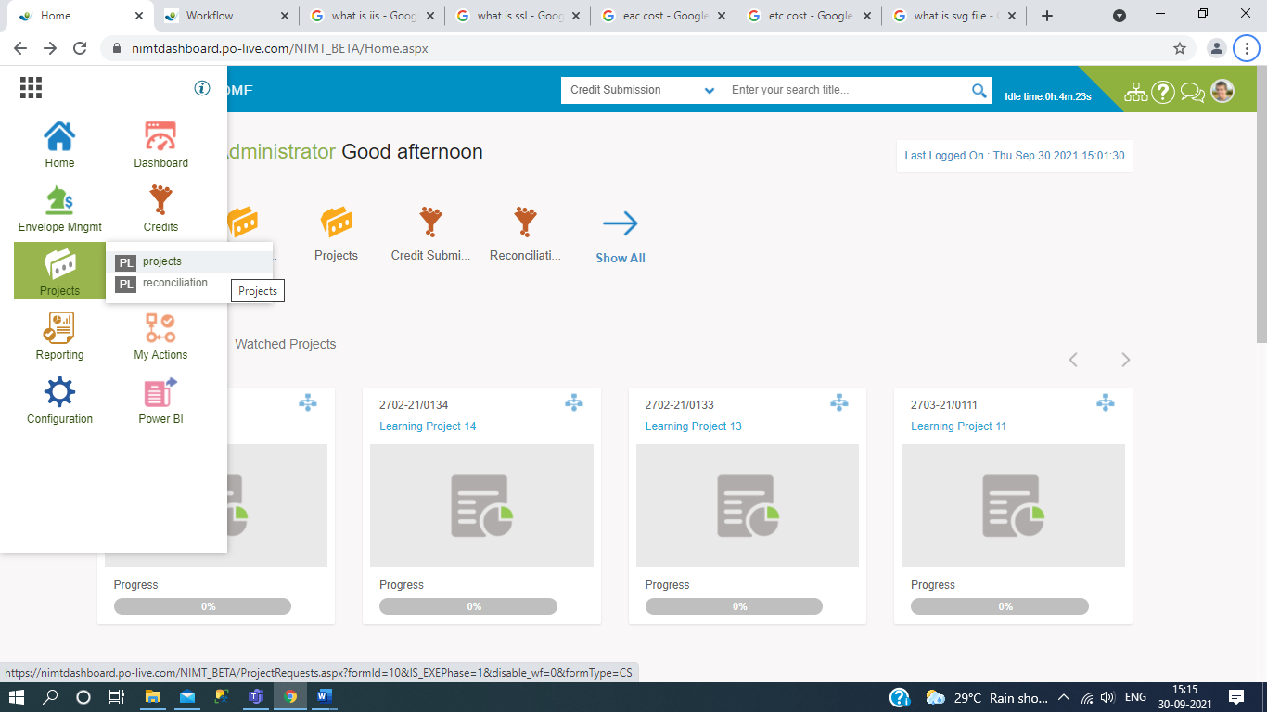

Here is the end of credit submission and from here is the start the project Section work.

# Introduction & wORKFLOW OF pROJECT Section.

This process starts after Submission of budget request and then we will actual works on main project and In this we are define EAC Cost means whatever we were defined original budget in credit submission, In this EAC cost will be increase of investment types and their of subtypes values.Now here we start the process and understand the workflow and functionalities.

1. Then after Releasing submit request approval process this is visible in Project Section and we will proceed the Project in Menu click and Title in project list shown in Draft.

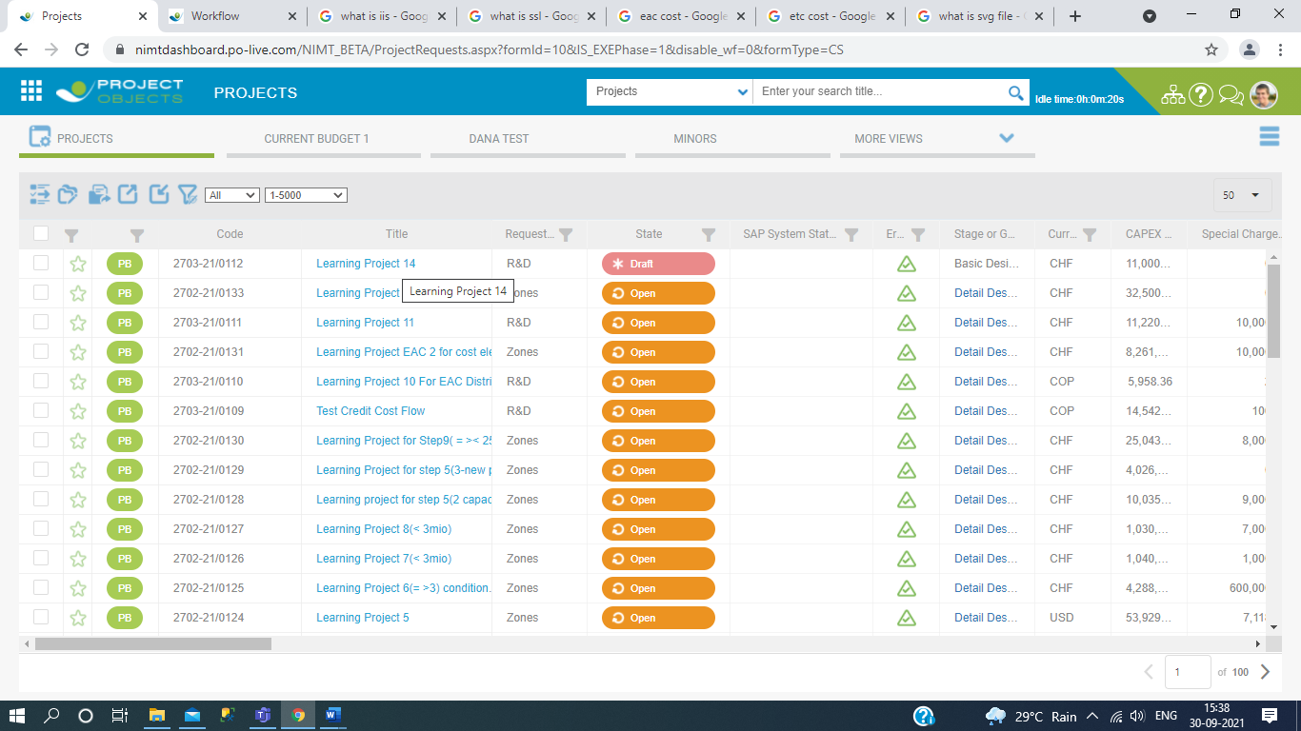

1. For remove the Learning Project 14 Draft we will take a last step of release process. Now we click on checkbox paroral of Learning project 14 and then click on Release Icon and refresh.

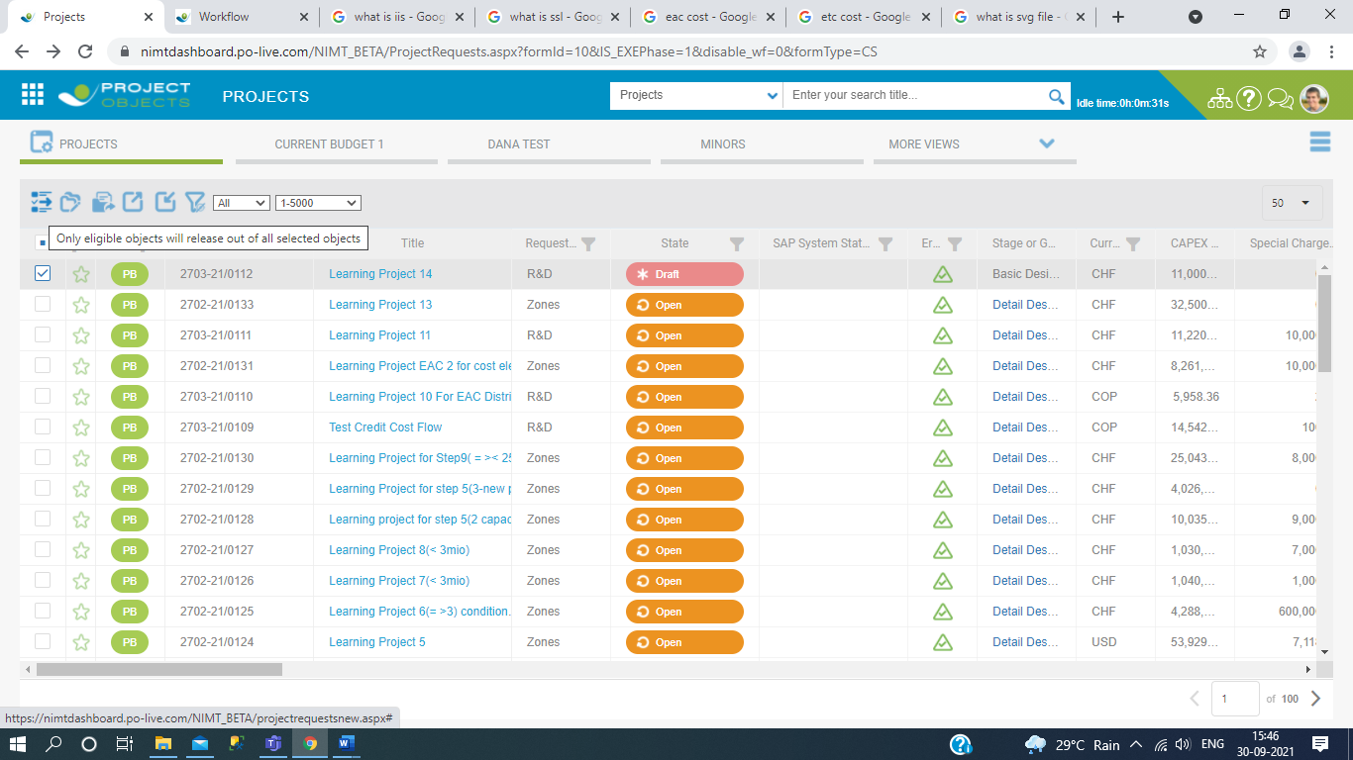

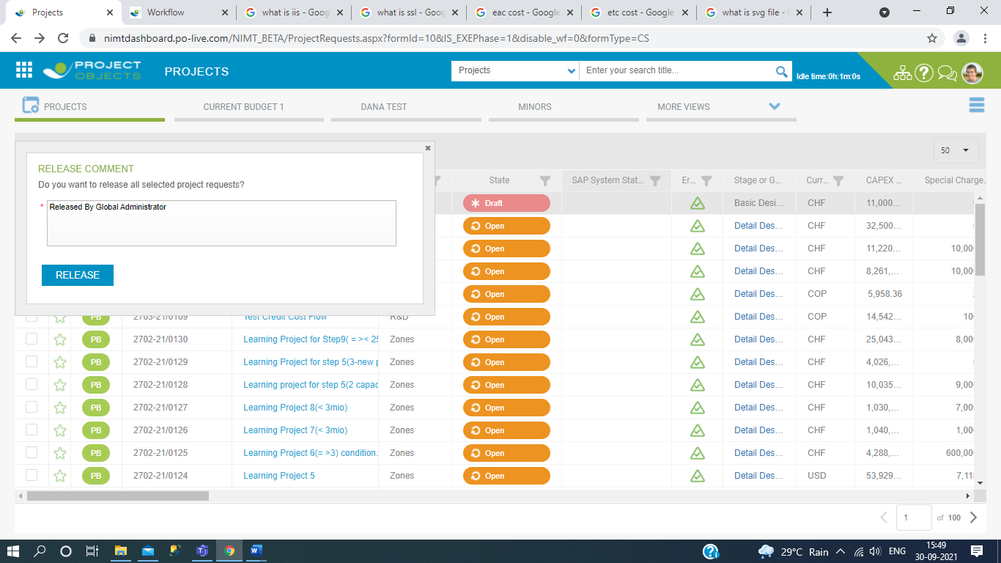

1. Now we see that the Learning Project 14 of state status is Open.

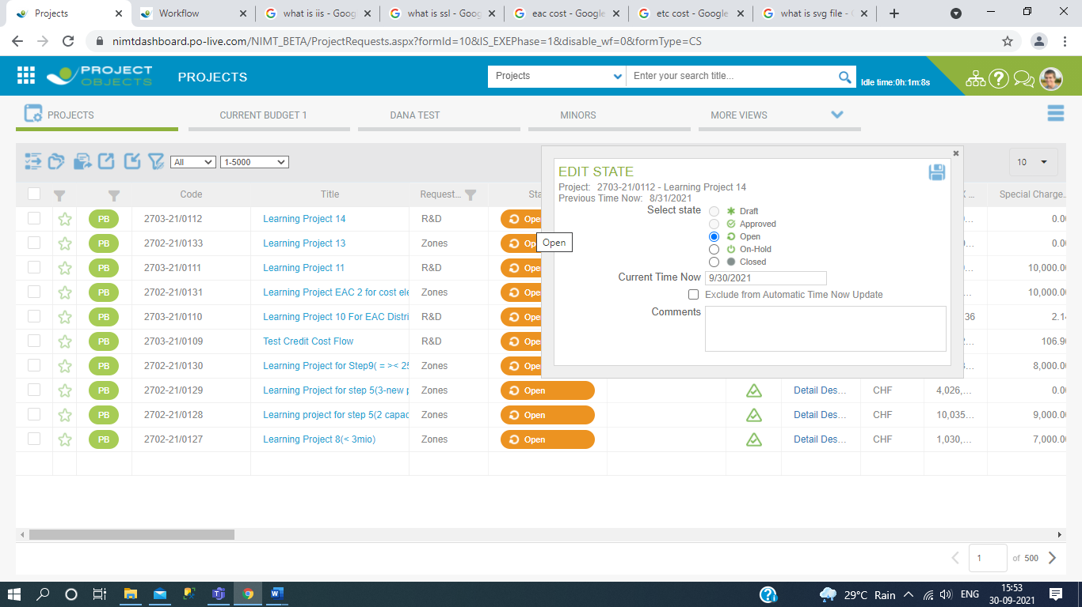

1. Then after we click on project and add the custom cost element & create the subtypes of their Investment types , we also create multiple subtype and Subtype custom element in cost planning section.

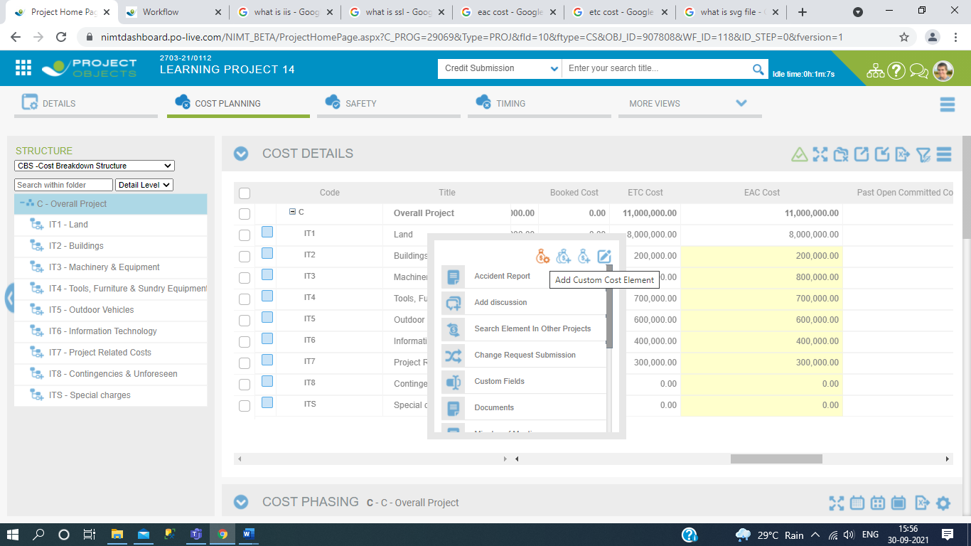

1. Now click on the add custom cost element and filled the details then click on apply icon button.

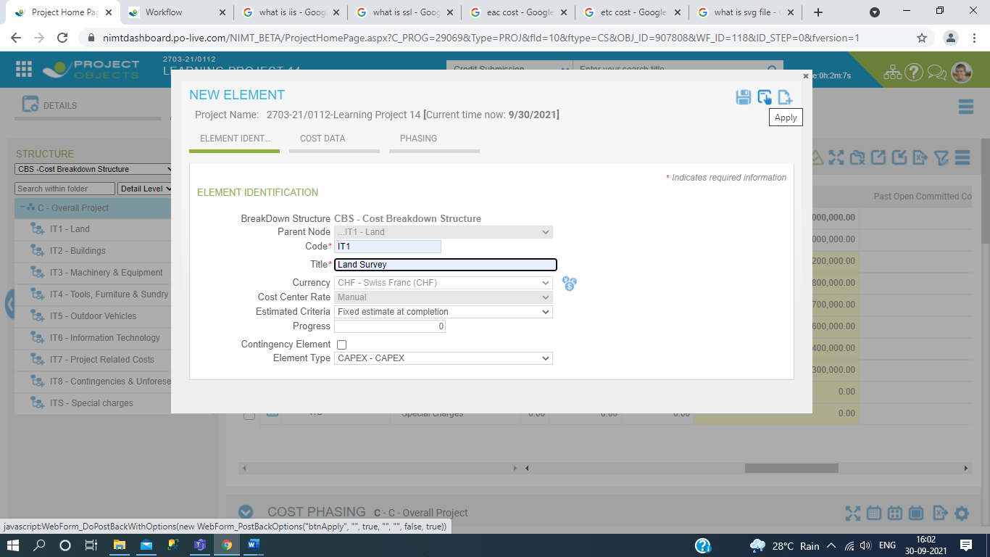

1. Now we can see the the sub types of their Investment types.

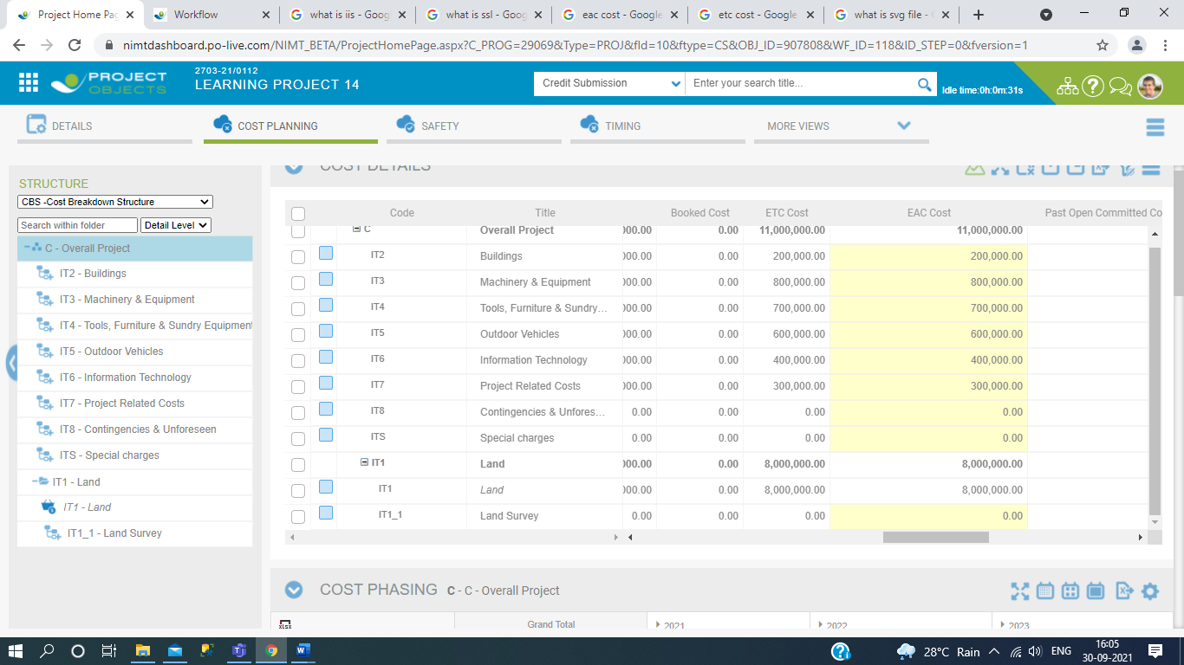

1. Then after we will define the forecaste values of their subtypes and matched EAC cost values with baseline Original budget and Current Budget.

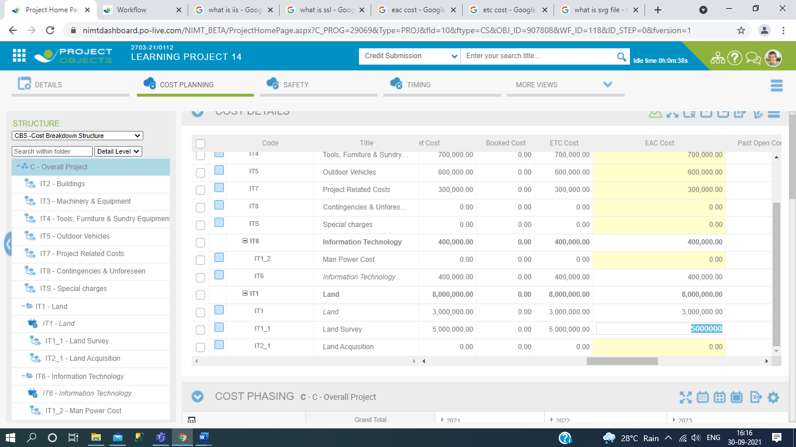

1. In this we take the value in increase form then overall project budget EAC Cost is increase compare to Original and Current budget.In this Original and current budget is not change before change request approval.And we also match the values EAC cost value with EAC cost and Current budget in Cost Phasing.

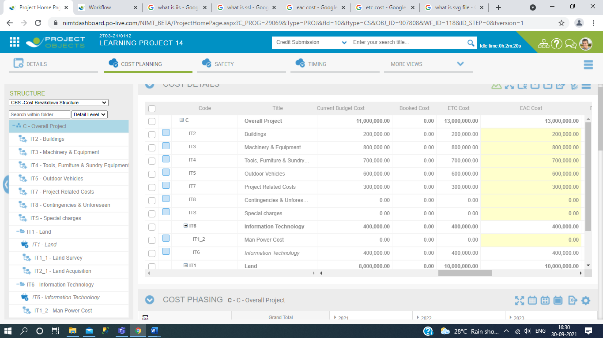

And in Cost Phasing.

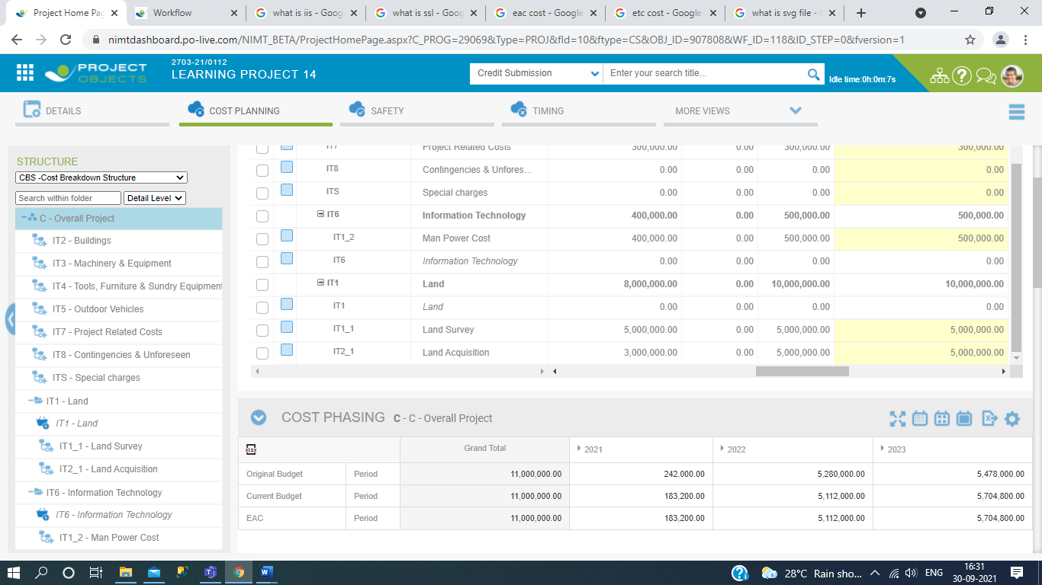

1. Now here is EAC Cost is increase and we have to required approval request. So first we go to Change Management section and add the change request and process the cycle of change request approval process.

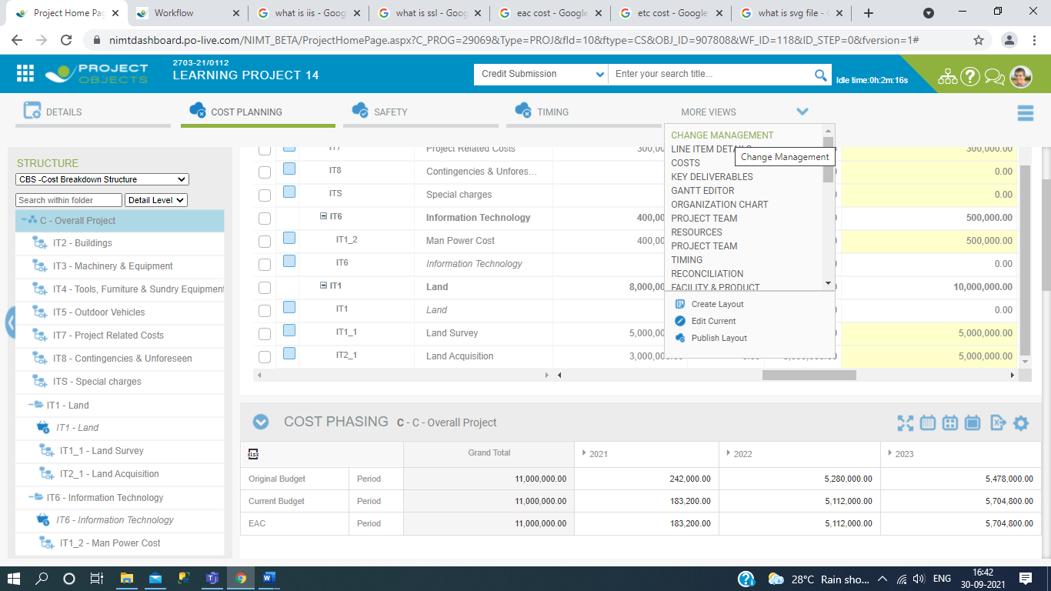

Click on create new.

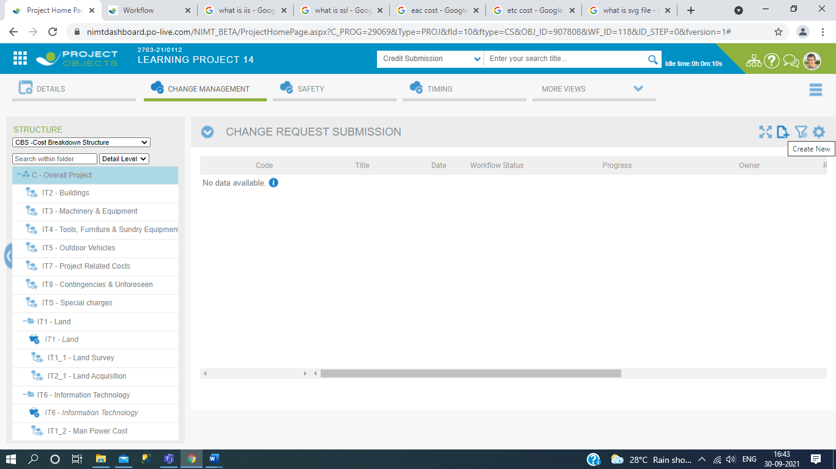

Then fill the details and click on apply.

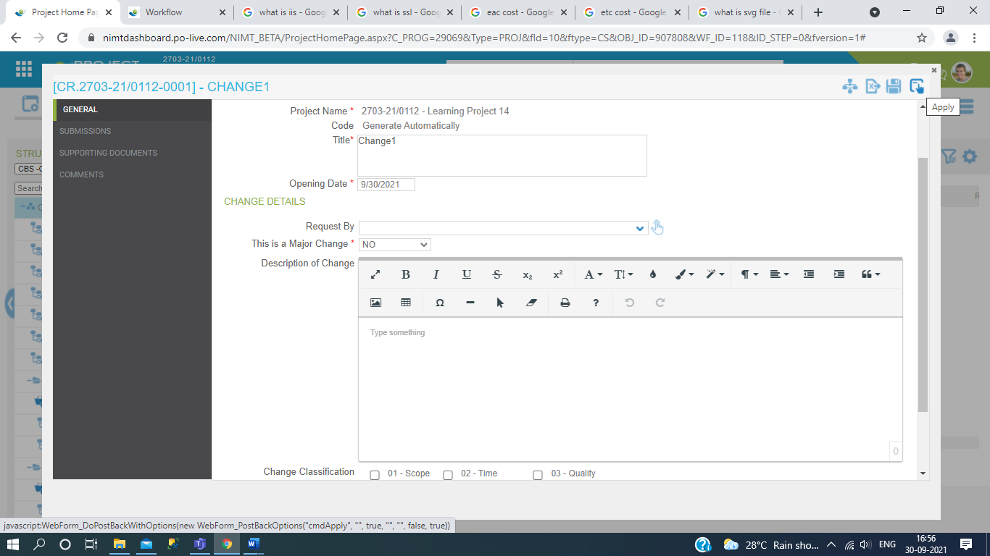

And click on Submissions and see the differences of additional values.Then Click on the workflow management.

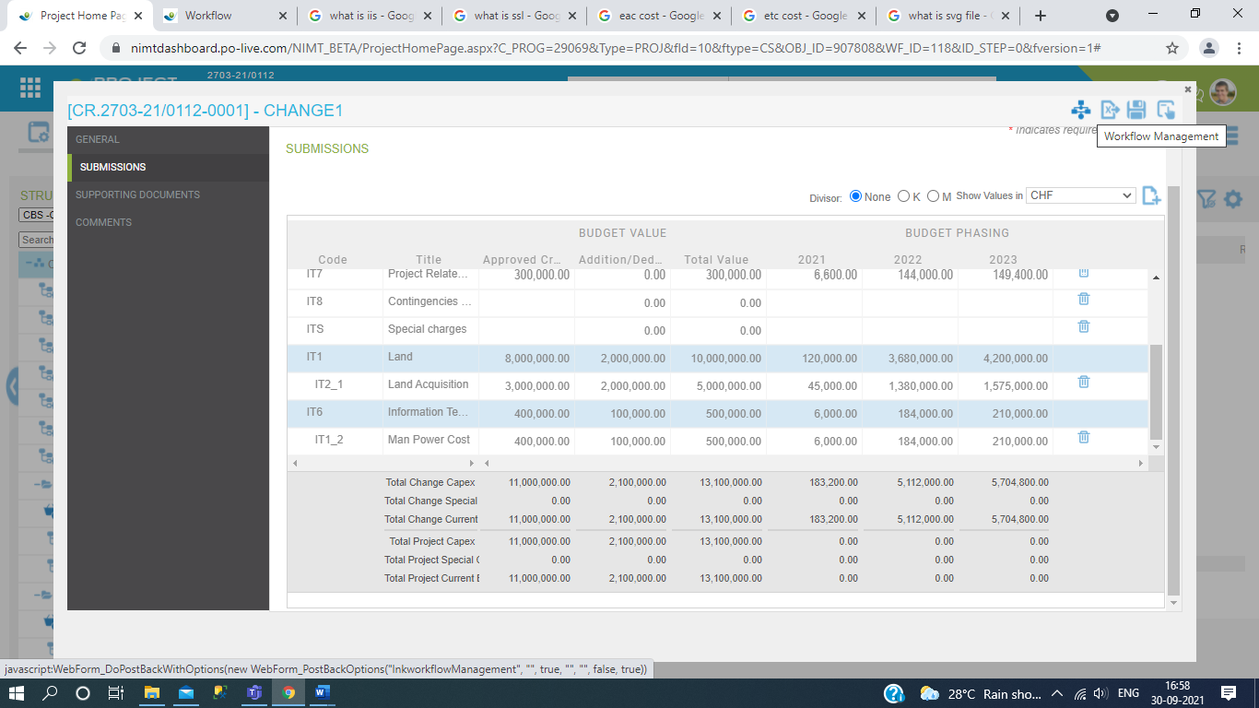

Then after Release all the approval request with Workflow Decisions.

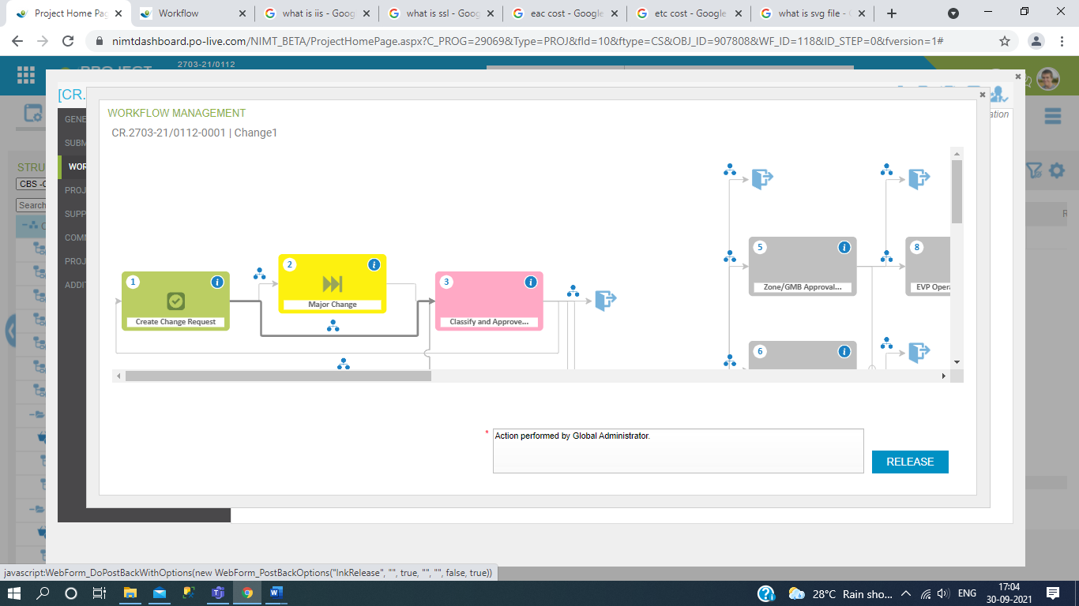

And after releasing process then see the Change Request Submission progress column.

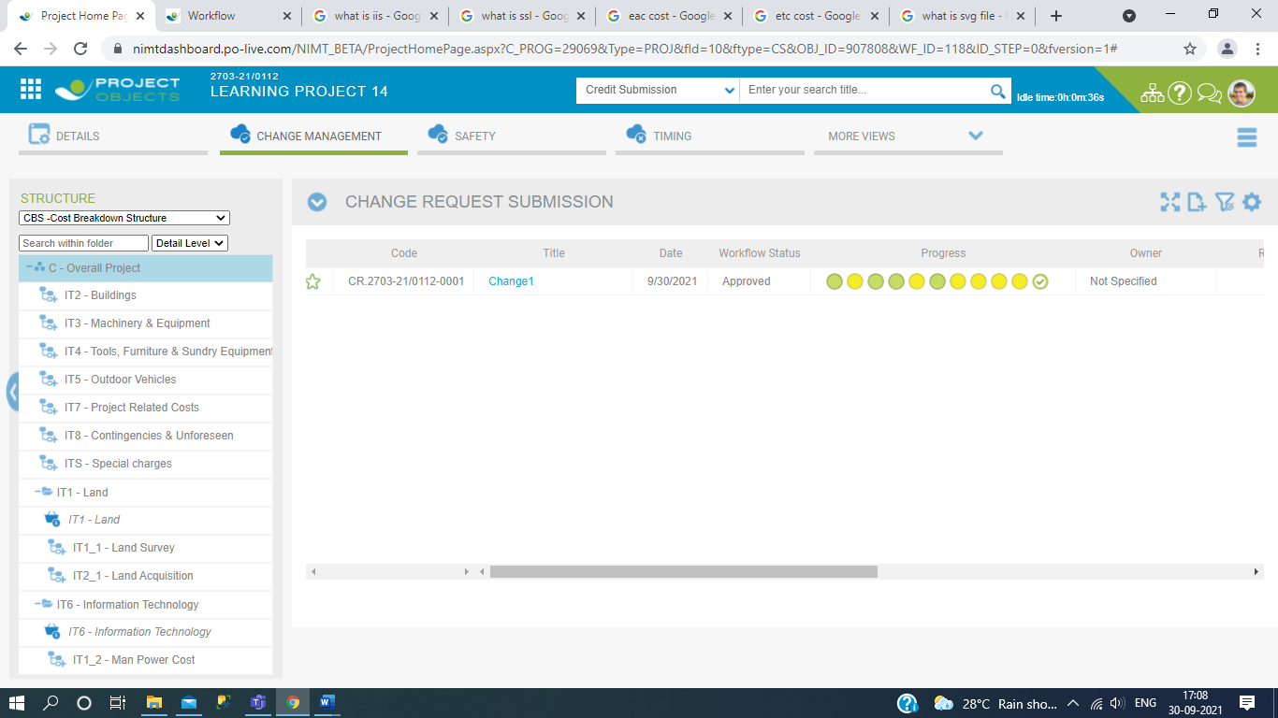

1. Then Click on Cost Planning Section and after change management request approval process we see the EAC cost and Current budget is same overall value but inthis case Original budget is not change and also match the value with Cost Phasing.

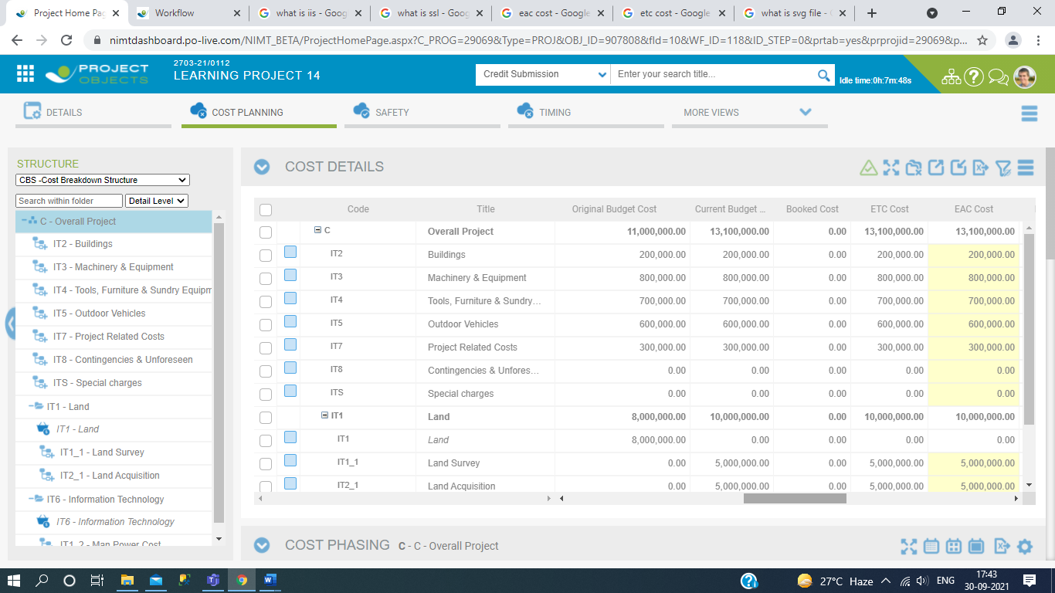

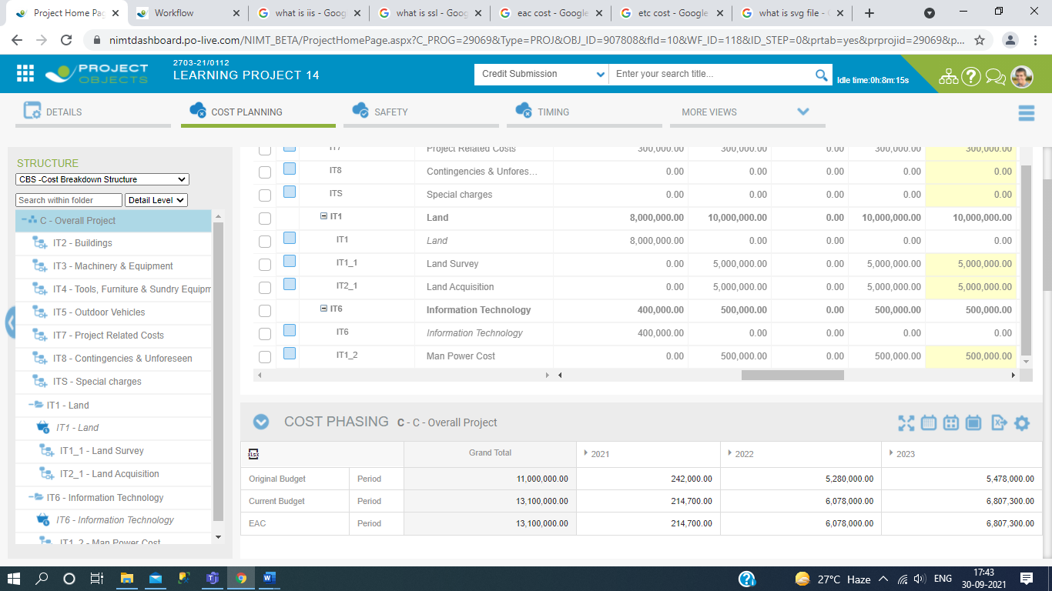

1. Then we will see the Graph Part ,It is total Update from based on Cost planning value after Releasing request approval process of change management.In this section updation graph mention like current budget, orginal budget and EAC Cost. It is update behalf Current value,Period and Years.

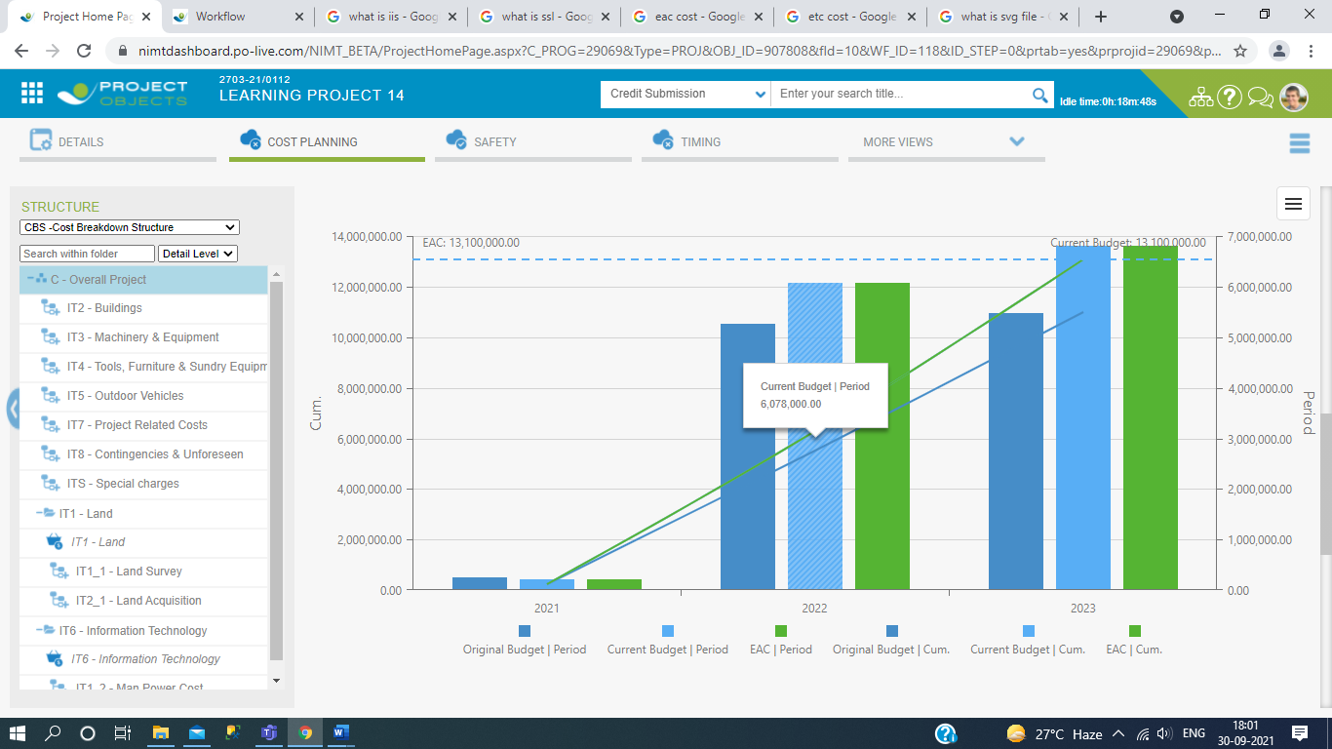

This is all about Workflow & Functionalities of Project Section.

Thankyou....

# FUNCTIONALITIES OF CHANGE MANAGEMENT.

In this change mangement functionalities is comes under project register, which is uses of required change request creation for when the EAC Budget is increase comapare to Current budget then require of change request. In change request we again passes the request approval process for increase budget and after this we see the cost mangement and compare to EAC budget and Current budget then you get same budget value of both columns. See below here start the functionality of change request.

1.Create new change request.

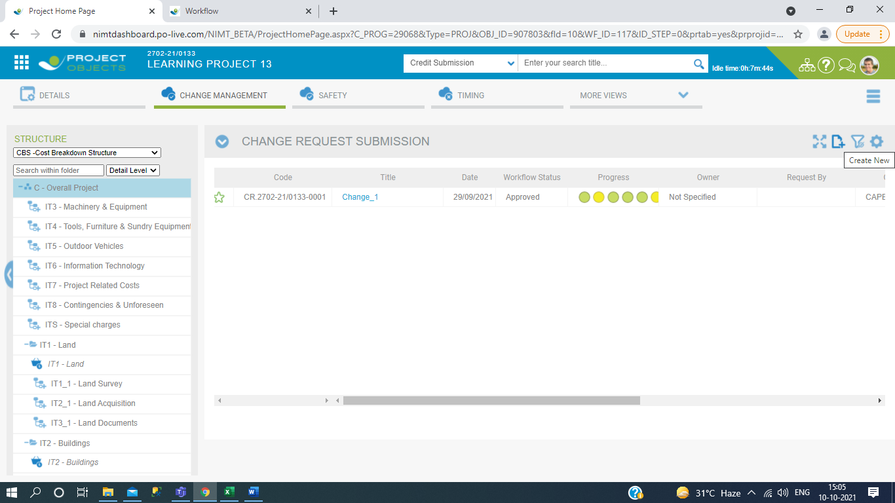

2.Filled data and click on save.

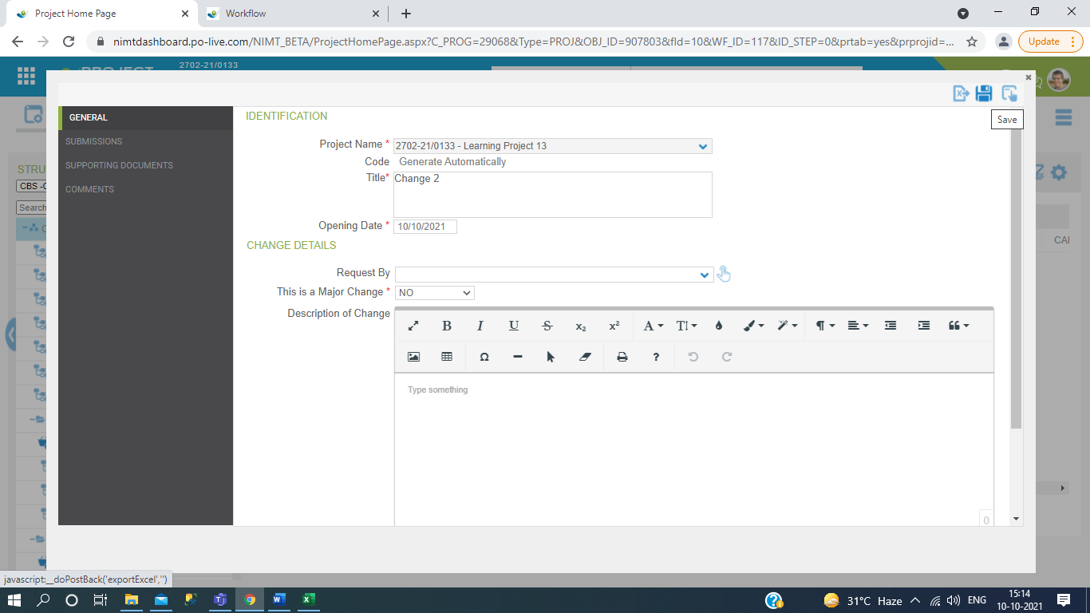

3.Start the release process.

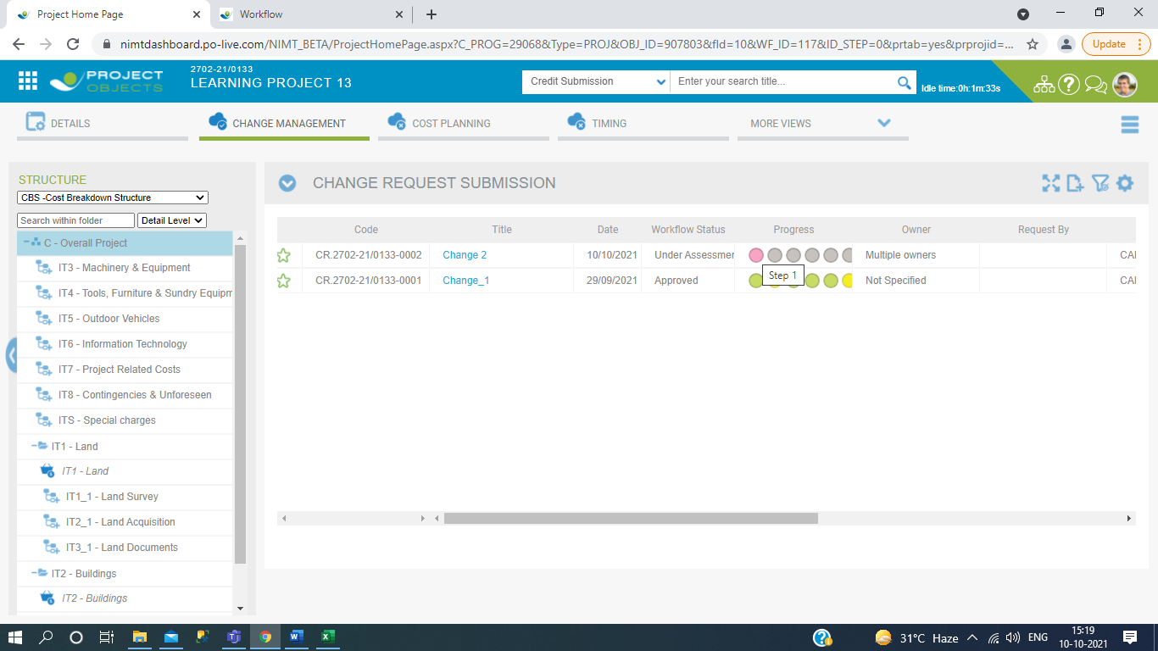

1. Then click on workflow.

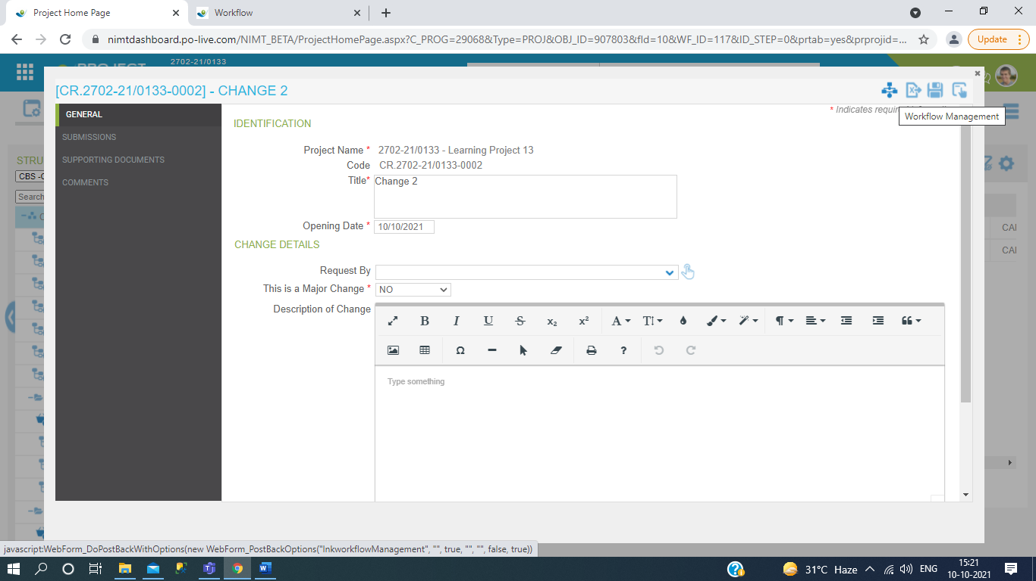

1. Then release the process.

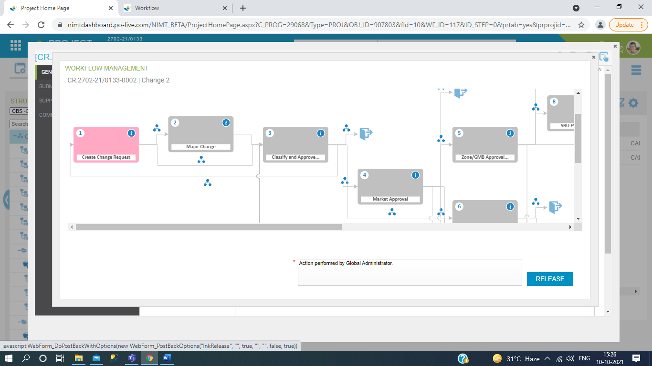

6.Release workflow decision.

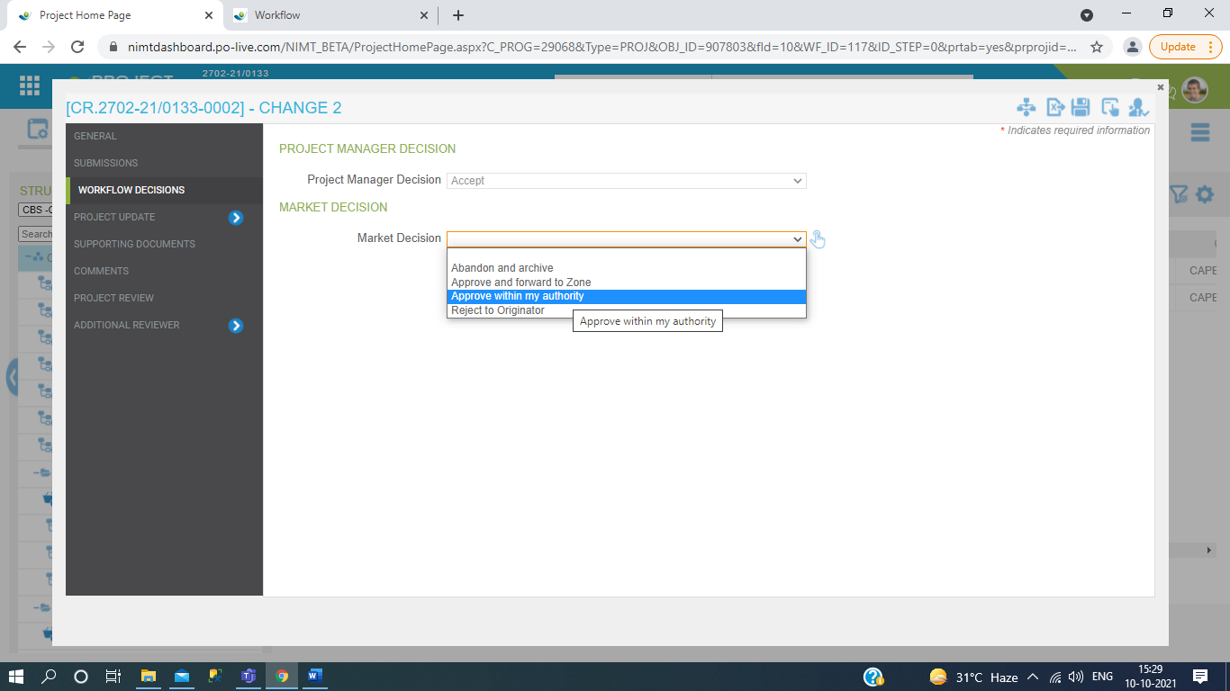

7.See progress bar.

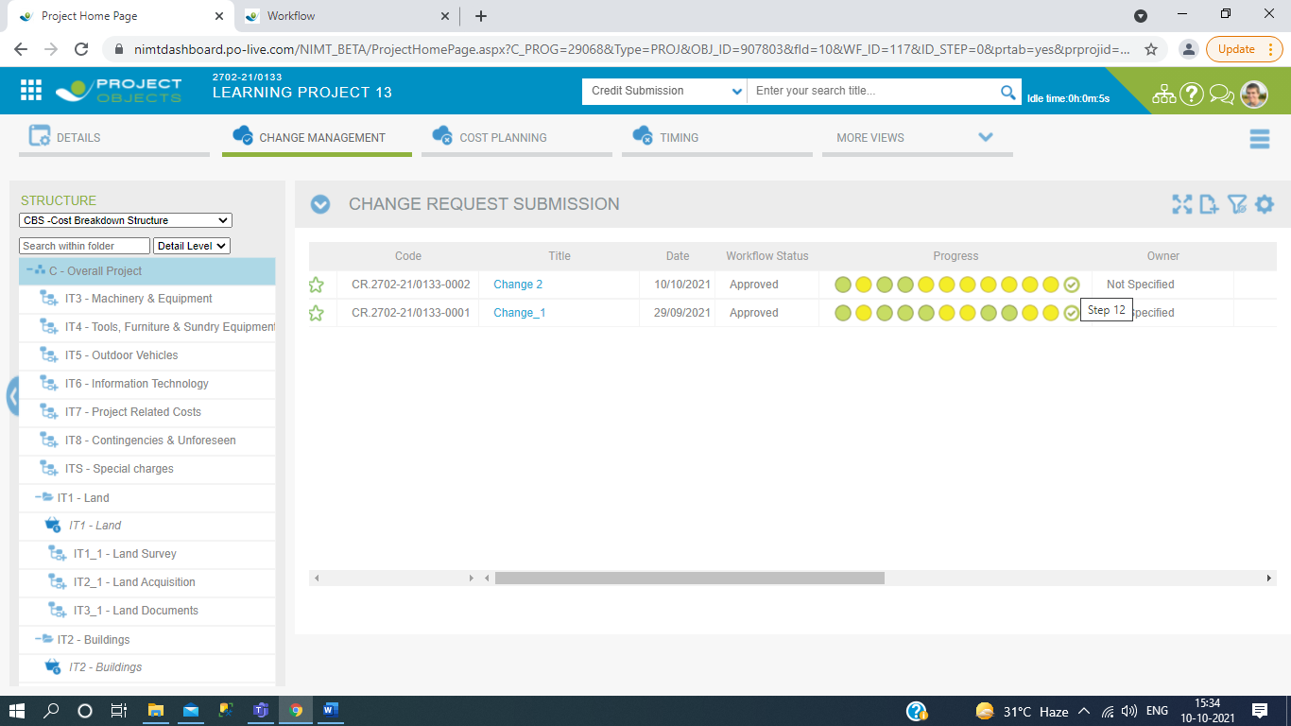

8. Then compare the EAC cost and Current budget.

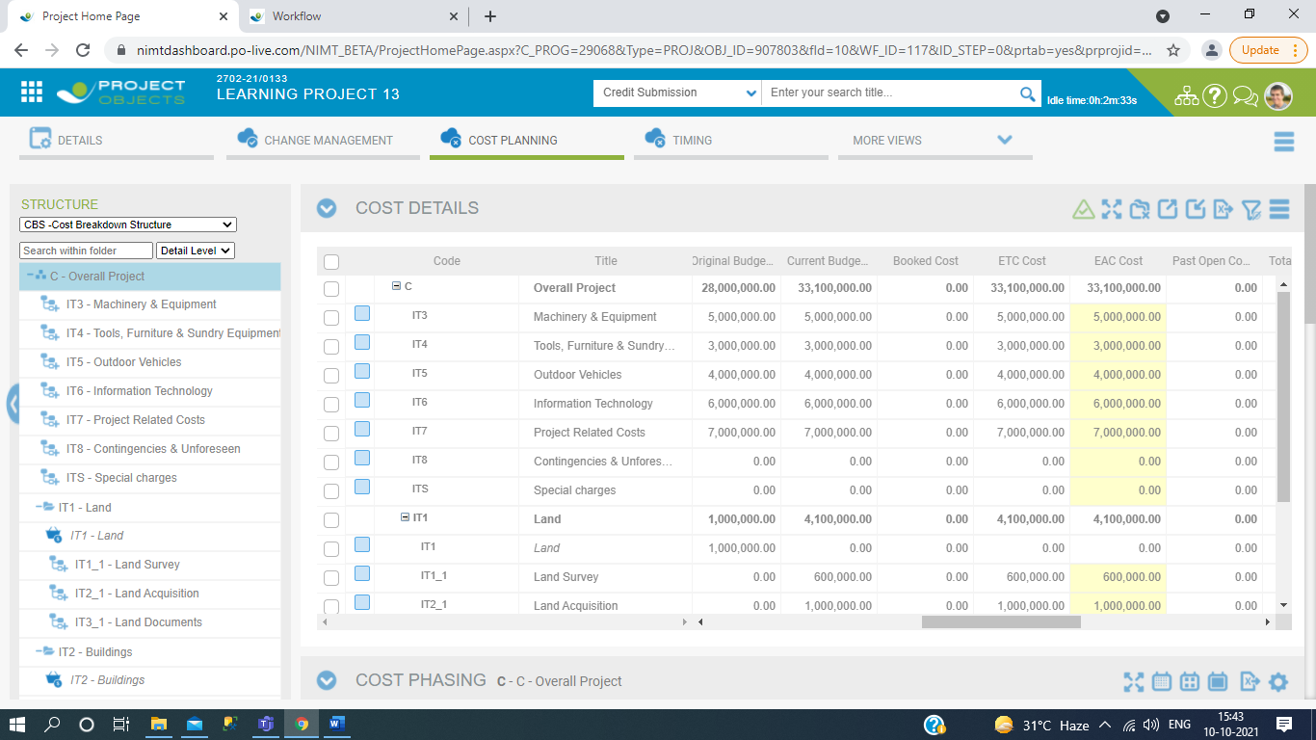

9. Both budget is same.

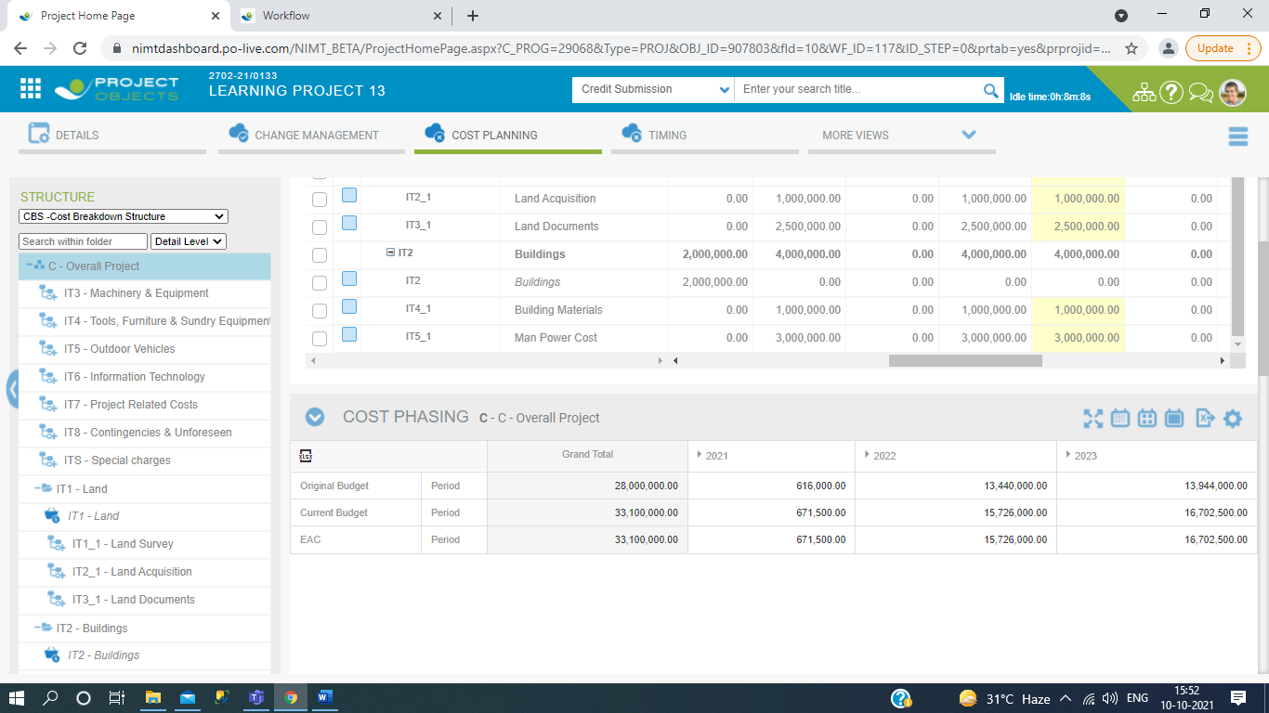

# FUNCTIONALITIES OF CURRENCY RATE CONVERSION.

In this we define the budget in multiple types of countries currency and main original budget is define in CHF (Swis Frank) Currency. So we required the main currency rate conversion of a year which is calculate the other country currency to CHF currency. Here below the functionality of currency rate conversion.

1.Go to settings.

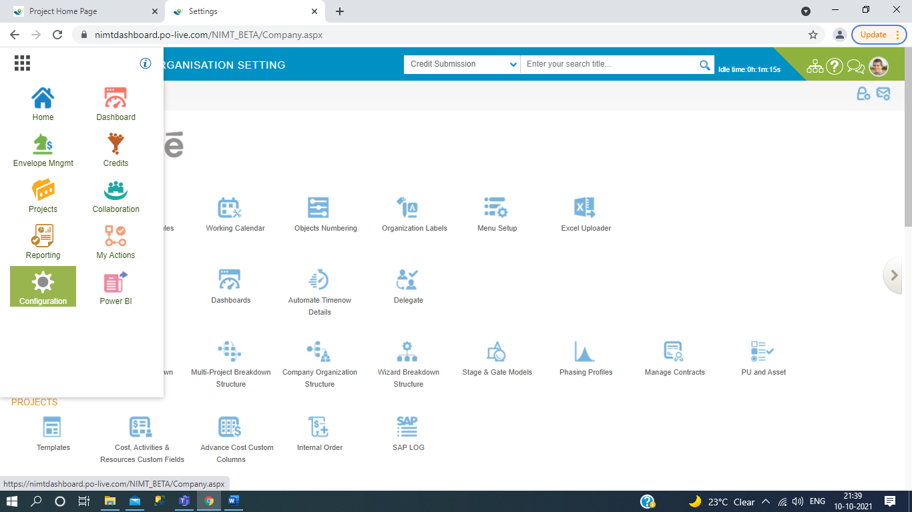

2. Then go to Standard Code in Global Standards.

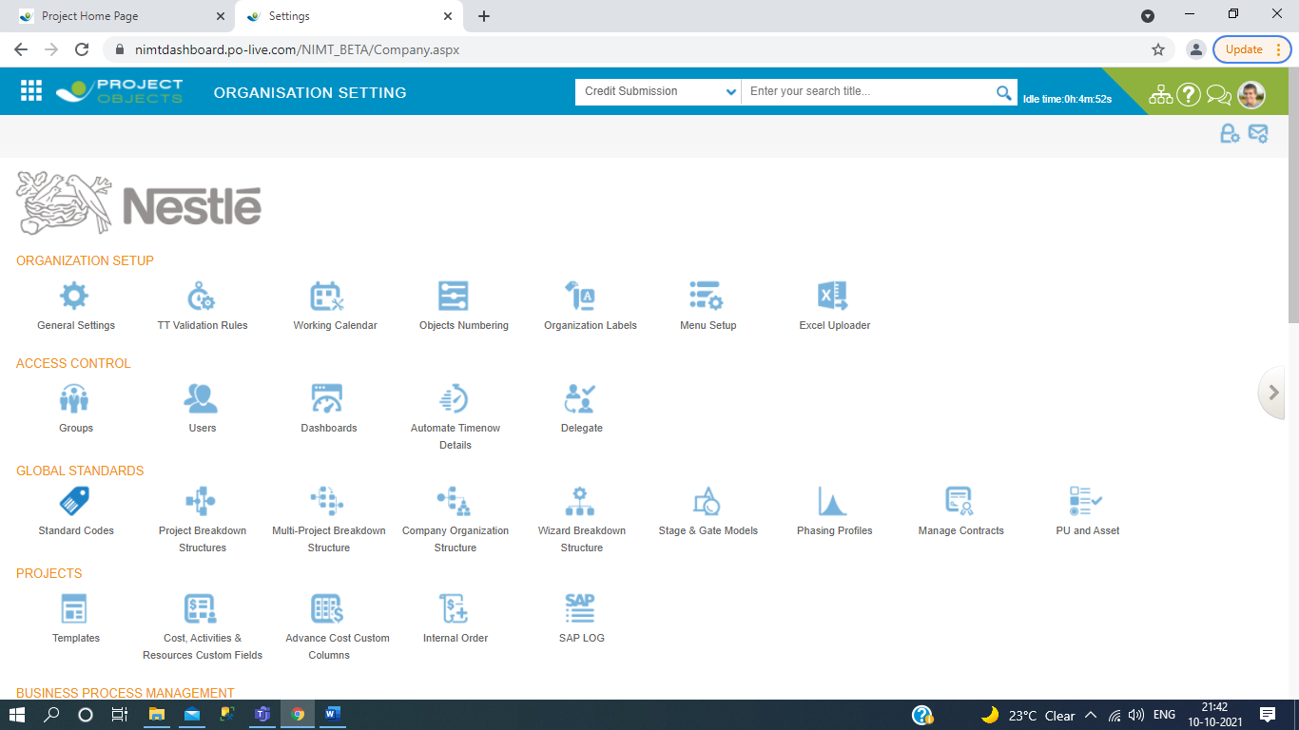

3. Then go to cost management and click on Currencies.

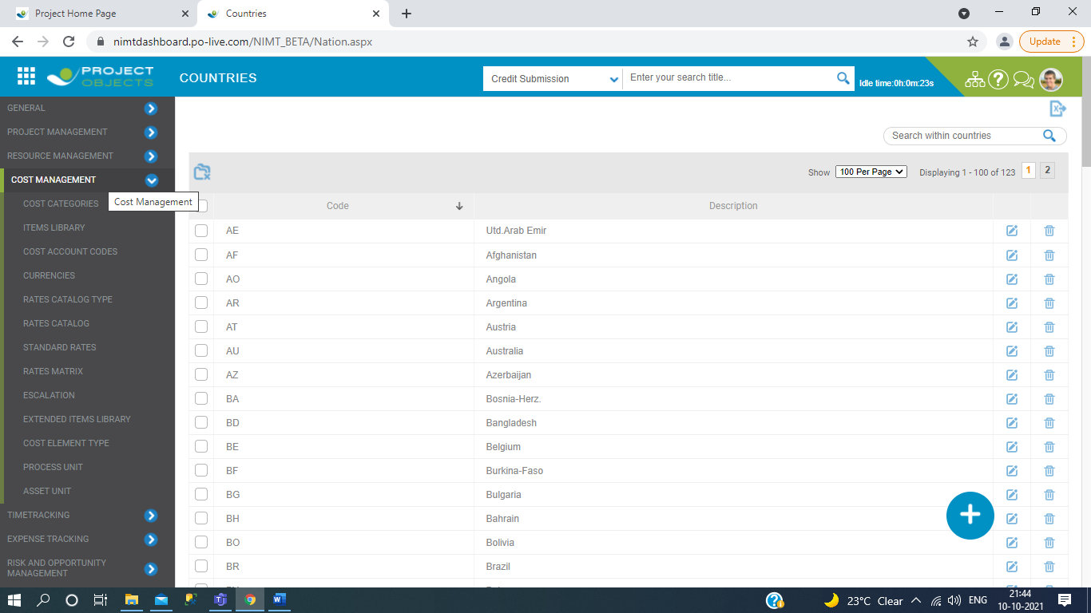

4. Click on that currency which one you have to take in your in current project, So click on budget details.

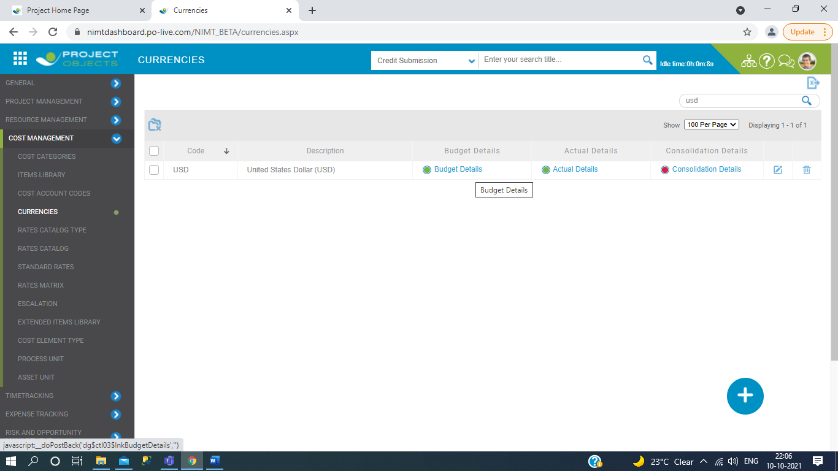

5.Then calculate the currency rate of multiplier of current investment year.

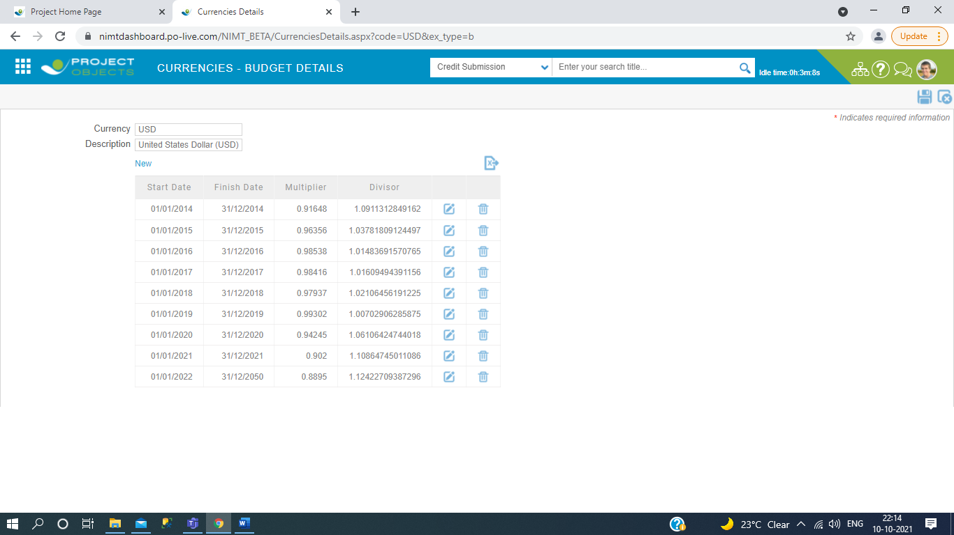

6.Then compare to cost planning of current project.

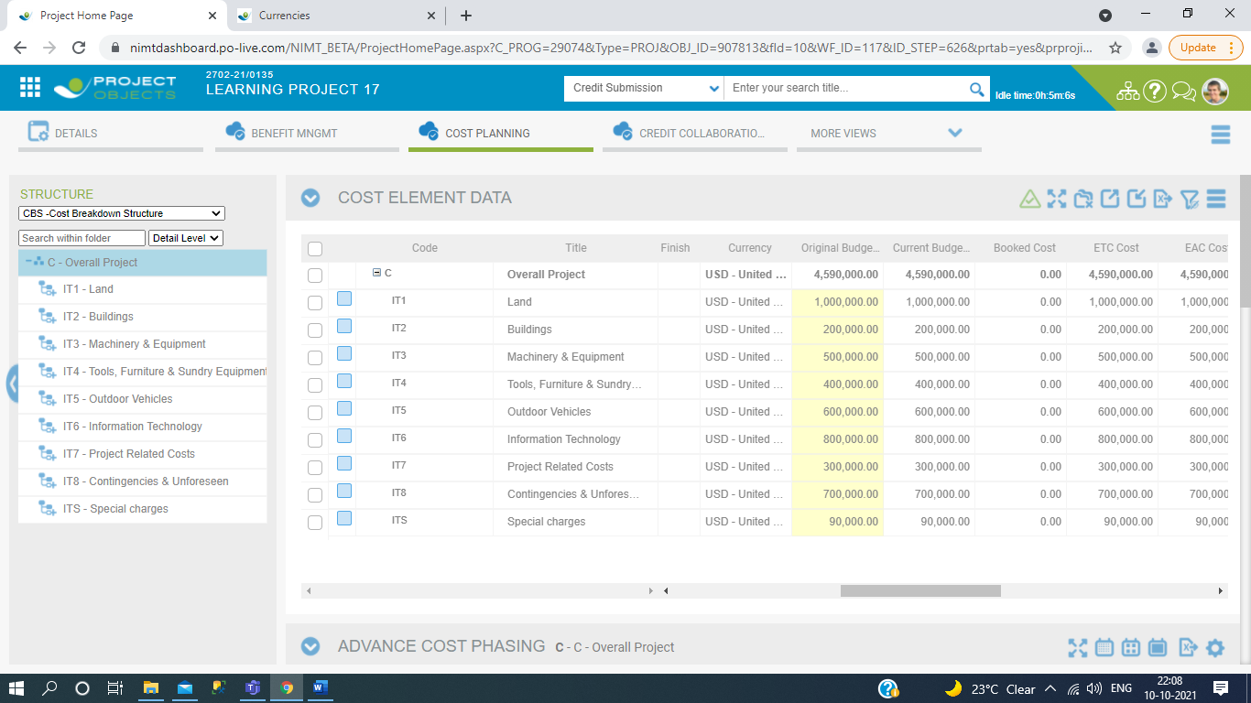

7.Then click on burger menu of cost element data, in this you can see the original budget and main budget.

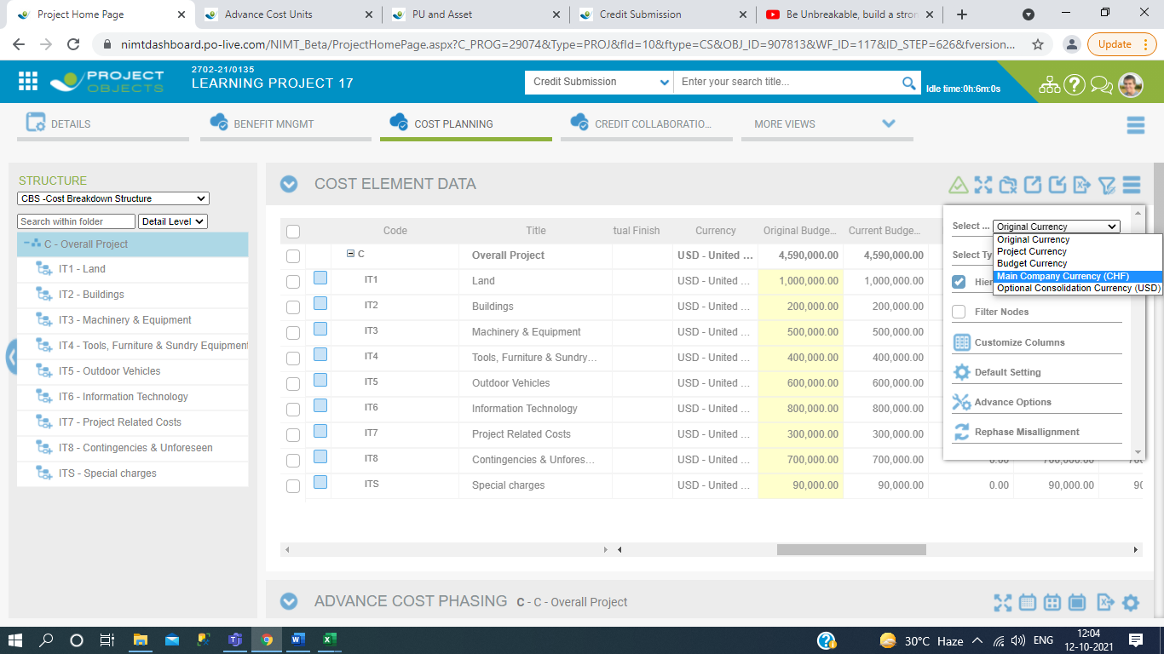

8. Then you should be multiply the original budget with currencies rate conversion of investment year.

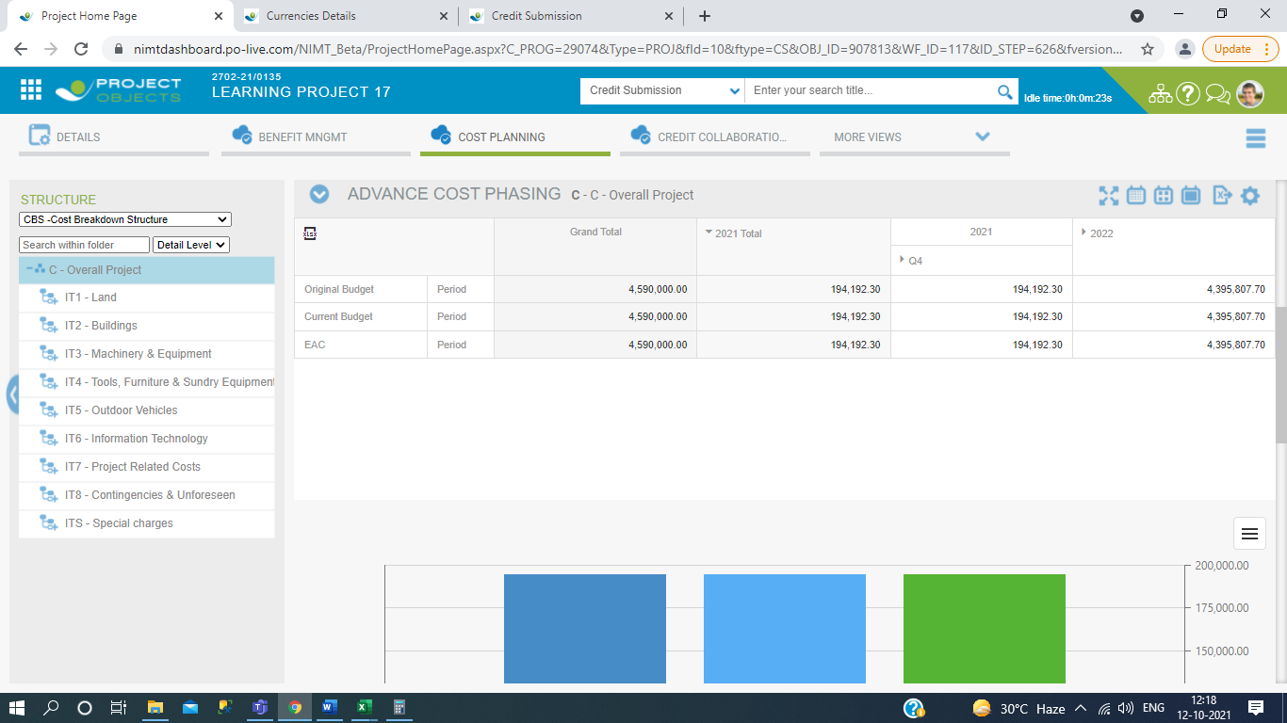

9.currencies rate conversion of year 2021 is 0.902

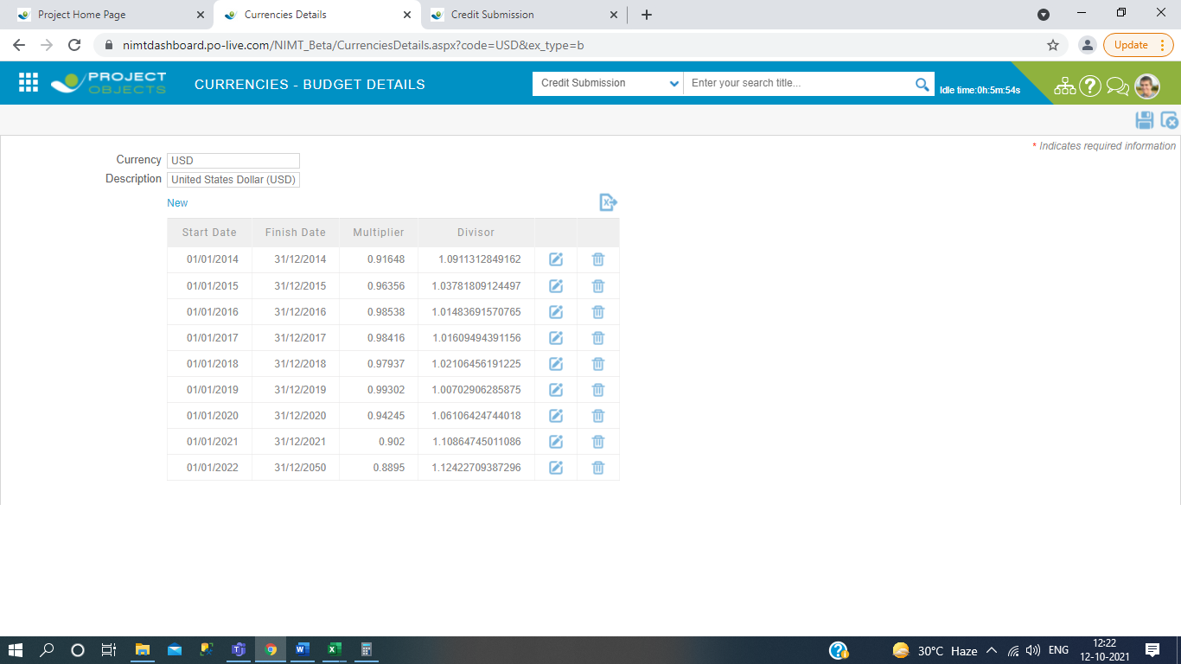

10. then multiply the 0.902 * 194192.30 = 175161.45 match with main company currency is proper or not.

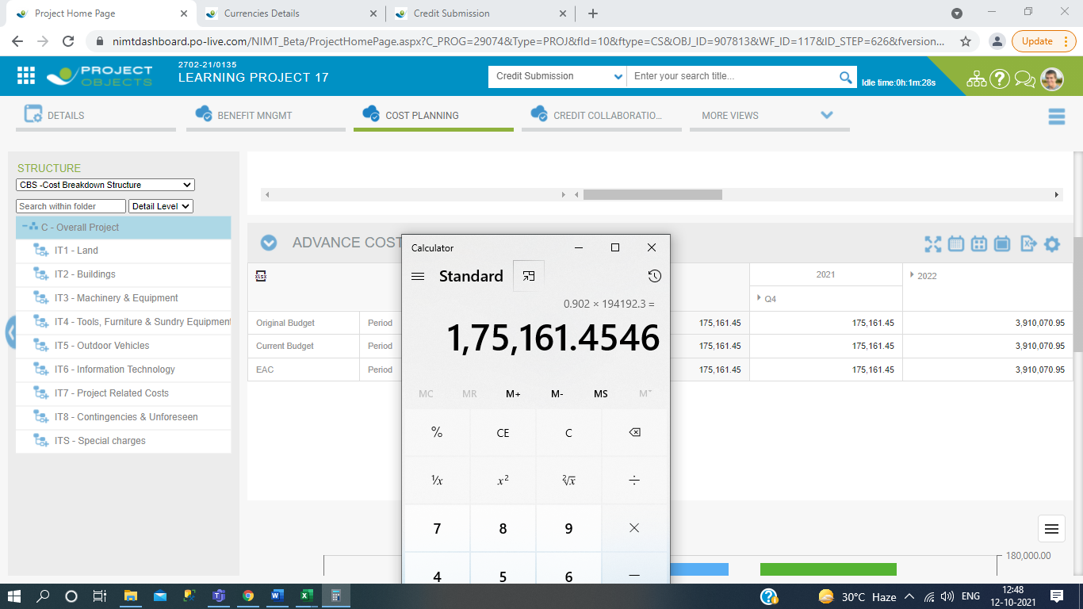

1. As it is you should try to multiply the values of cost phasing with currencies rate conversion year and matched value with main company currency.

So here is all about the rate conversion calculation with original budget and we try to put it every thing in this document.

# FUNCTIONALITIES OF Asset unit and process unit.

1. Go to settings.

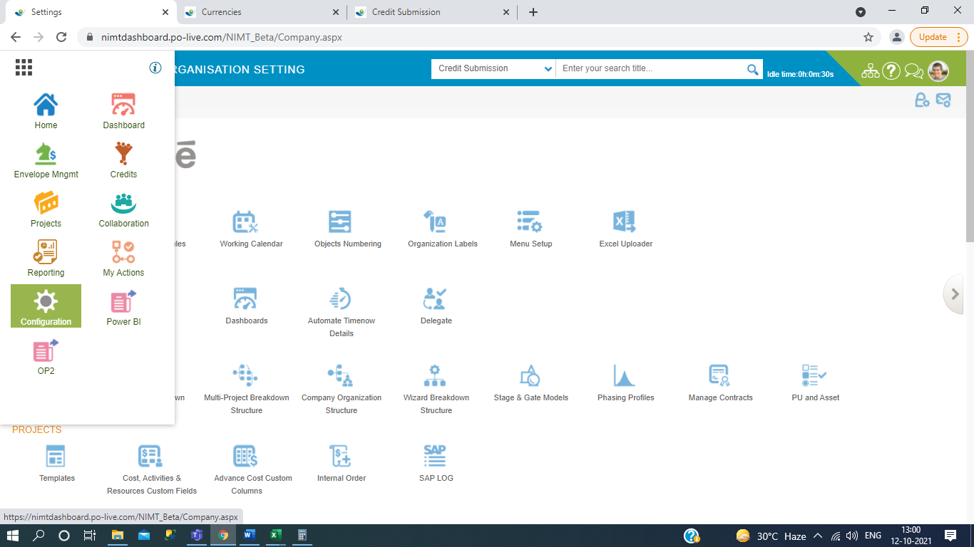

1. Then click on Asset unit.

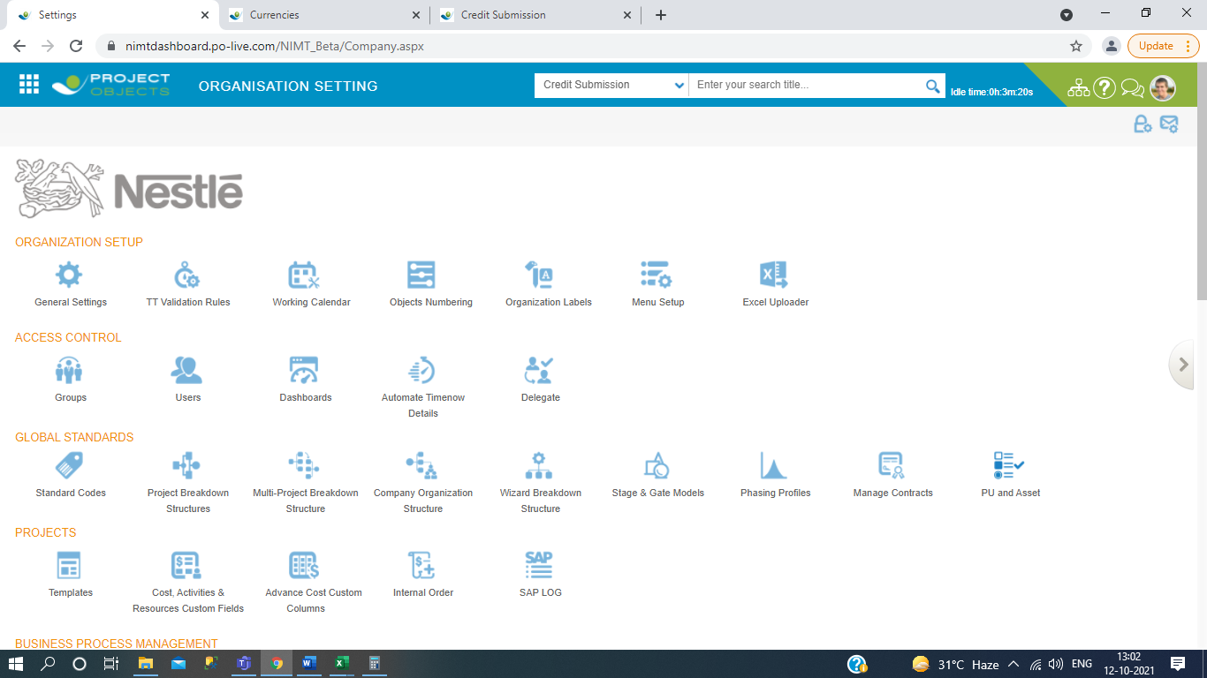

1. After this enter the which one code where asset code have multiple types of process code matched with there of description.

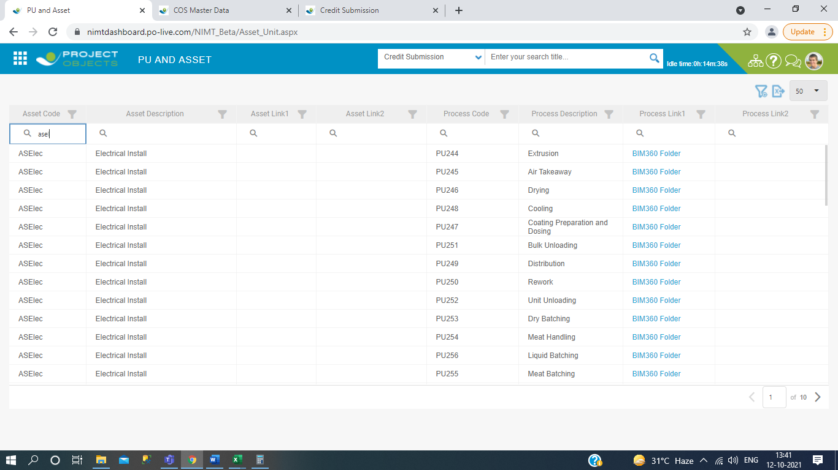

1. Then after you should be go to Standard codes in configuration.

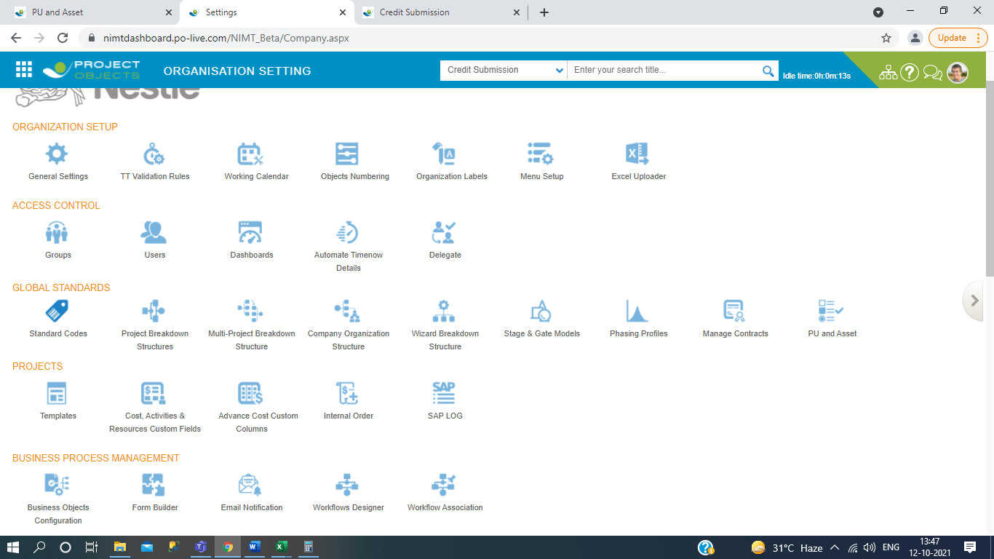

1. Then after you click on cost management and then click on subdropdown of extended items library then click on add button.

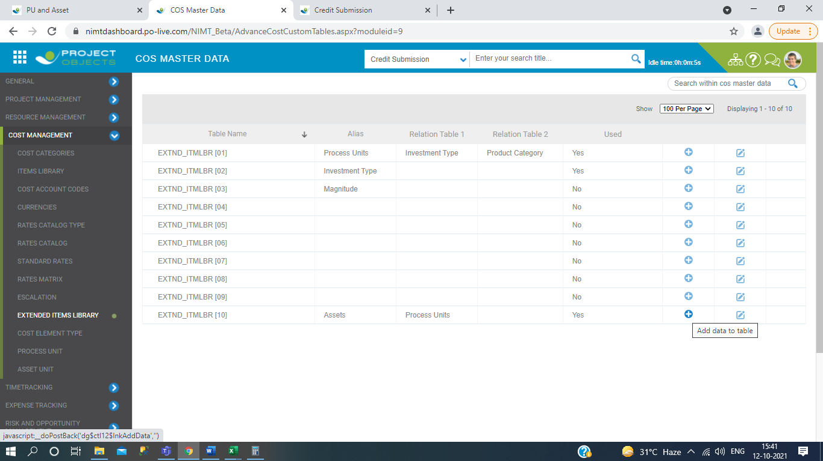

1. Then goto the search button and type, which type of asset code which is contain multiple types of process unit code.

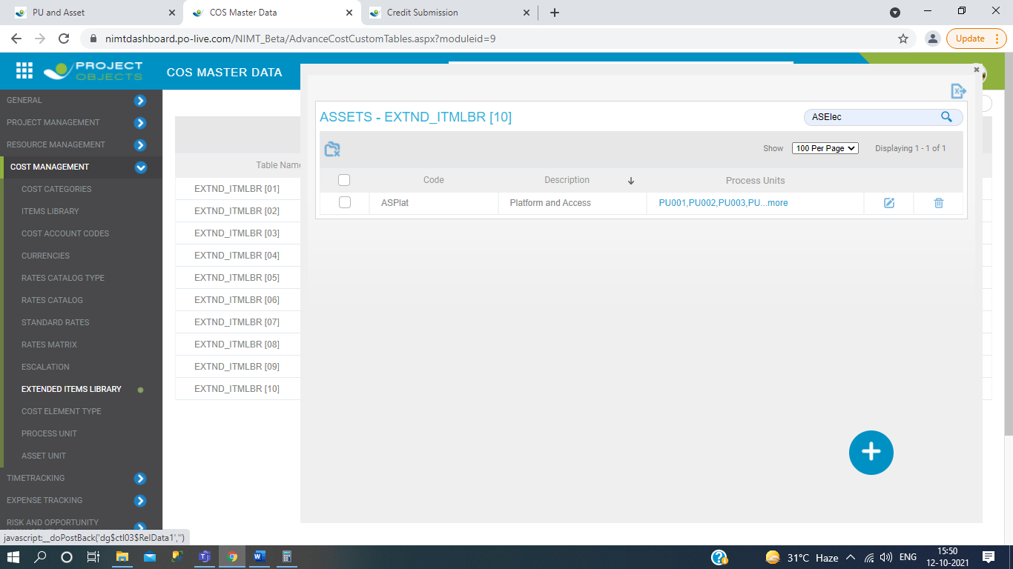

1. Then click on process unit codes and you see here the description of process unit code and don’t edit anything.

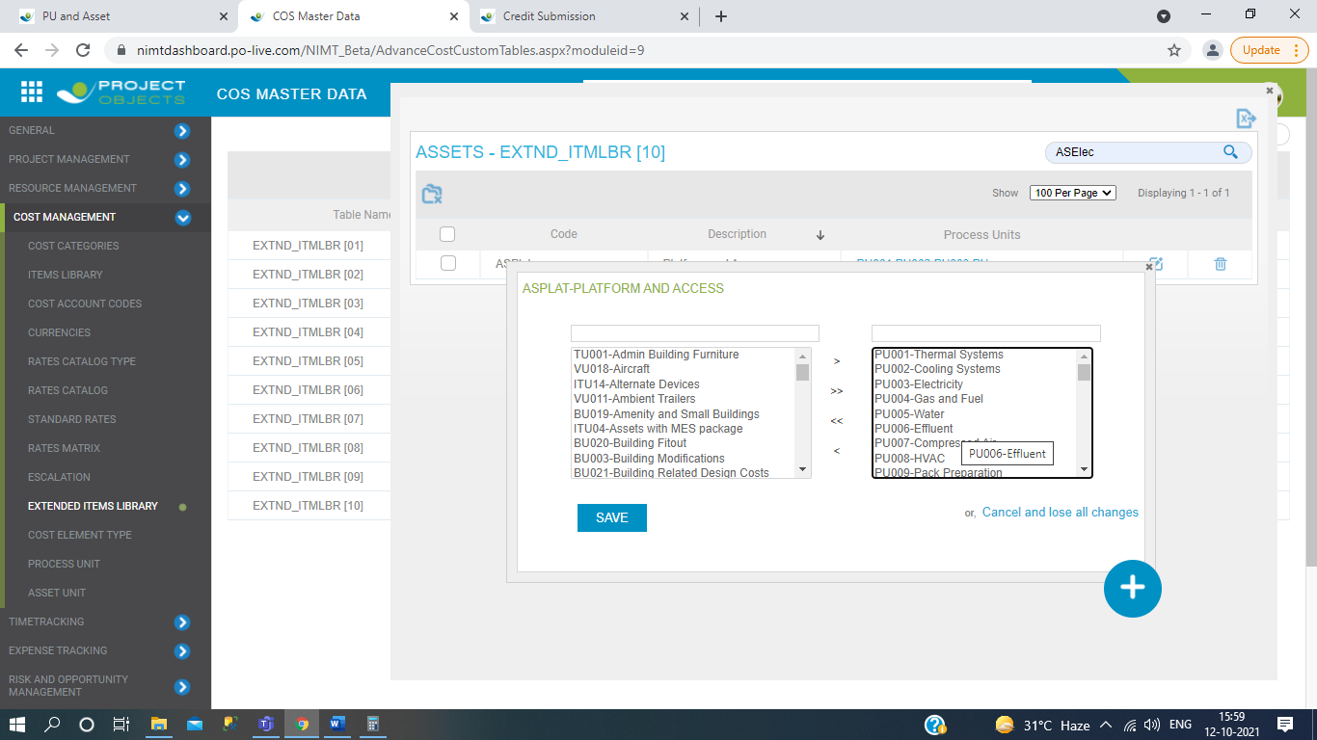

1. Then asset unit code of process unit code description matched with process unit page.

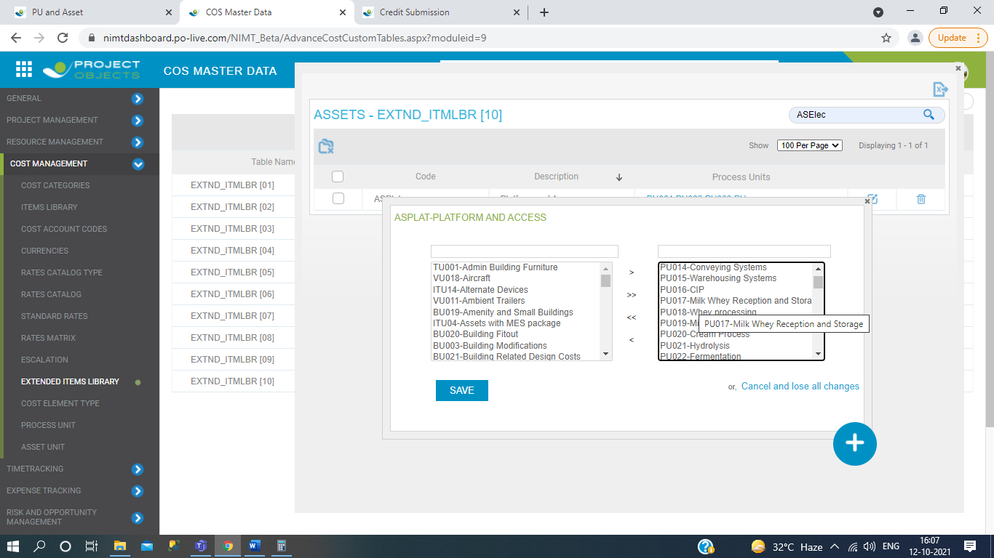

Matched with Asset unit searched by process unit code..

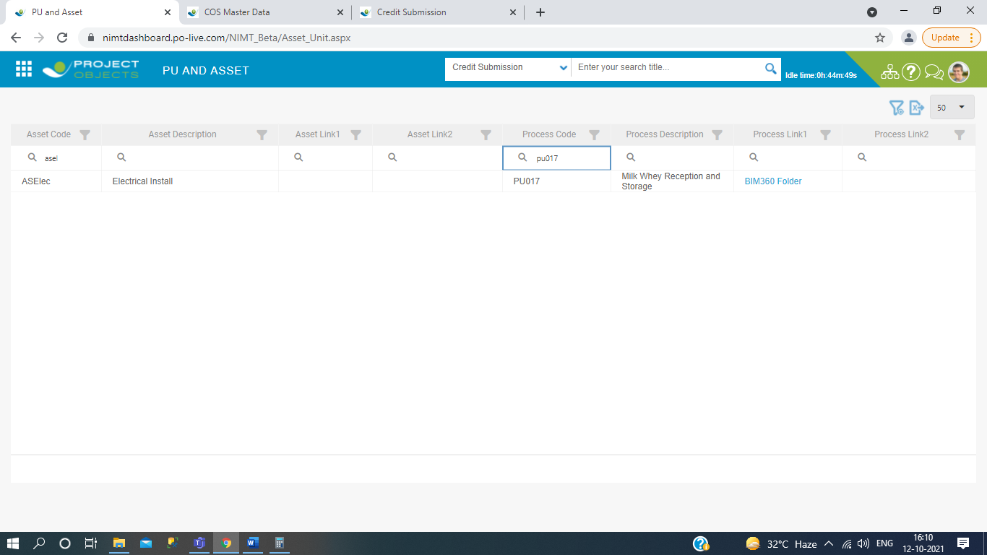

And then verify by process unit page search by process code.

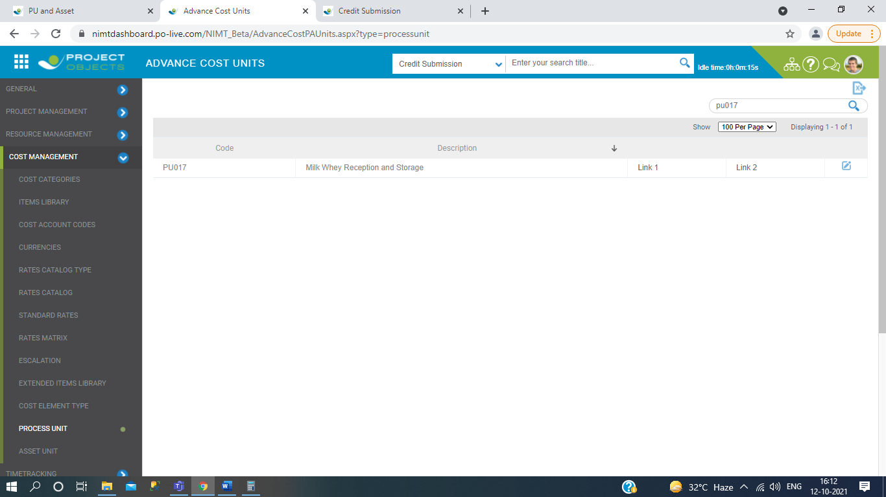

In this we verify the process decription of asset unit code.

So here all about the asset unit and process unit functionalities.

# FUNCTIONALITIES OF user and group management .

1. In the user mangement we are create the aunthenticate users for login page.

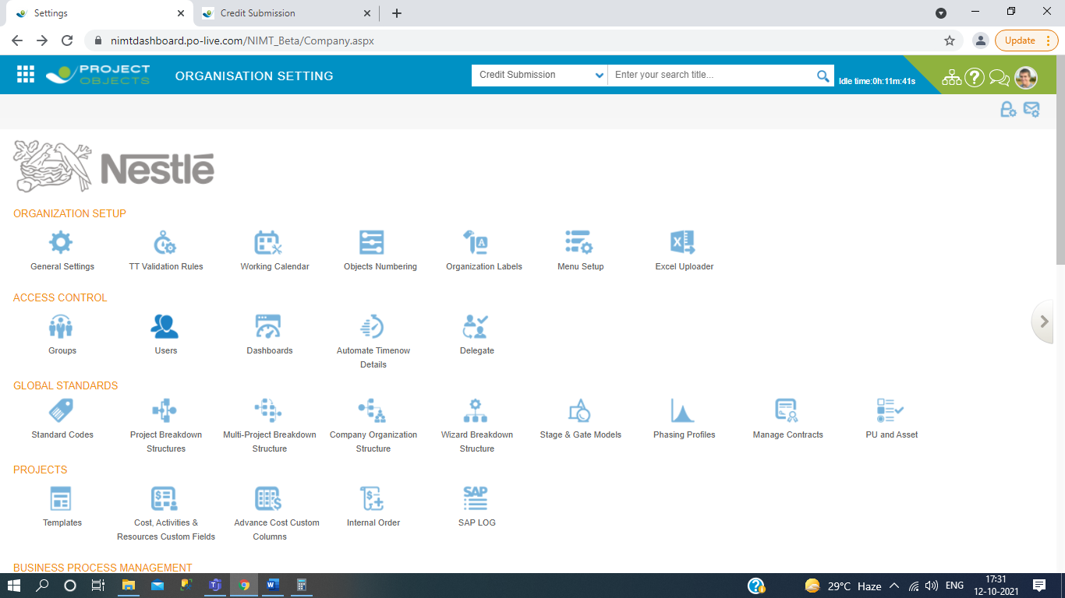

1. Click on Add button.

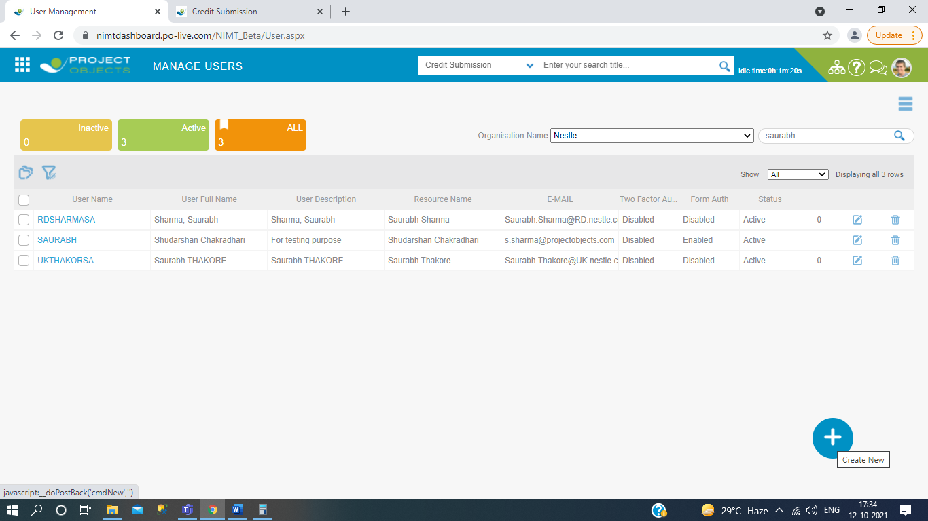

1. Filled general details.

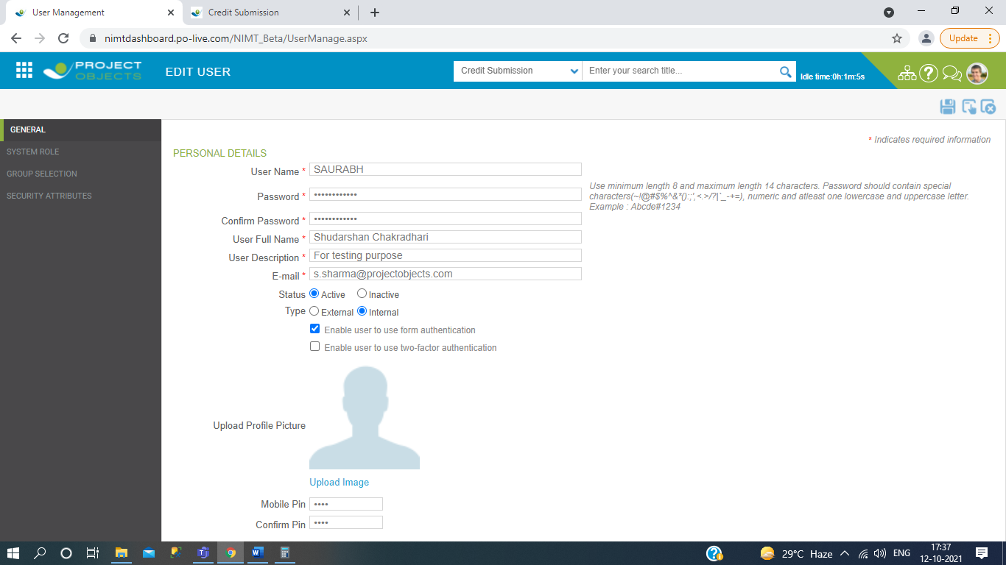

1. Then go to the System role.

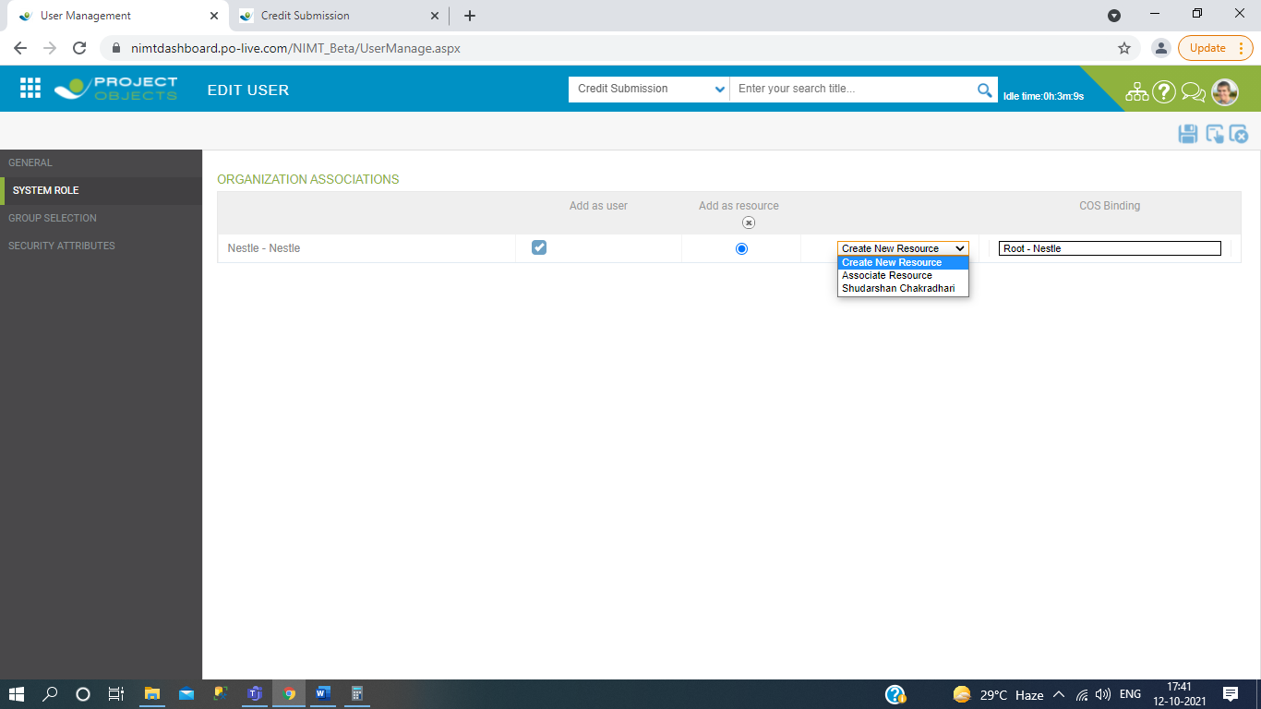

1. And then click on Group Selection in associated group and then click on root node then click on the checkbox which would you like to select.

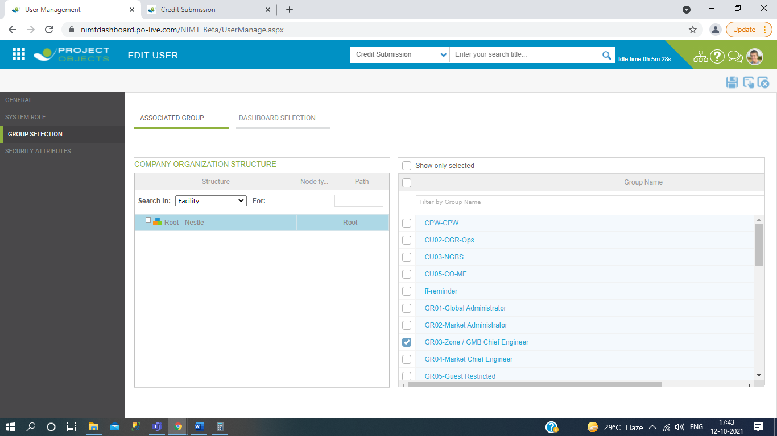

1. Click the tab Dashboard selection and you see the data which one you have to selected.

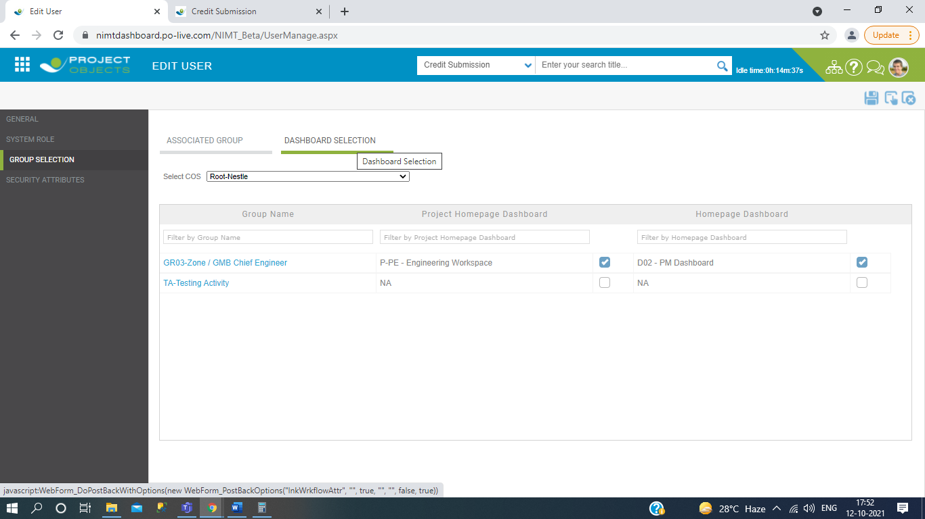

1. Then click on Save button.

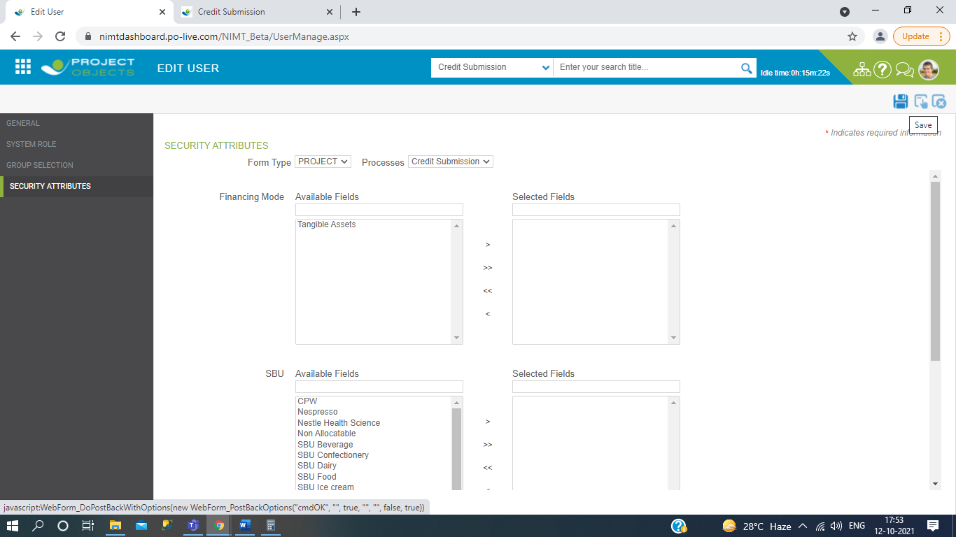

1. Then again go to the User homepage and see your user id which one you have to created.

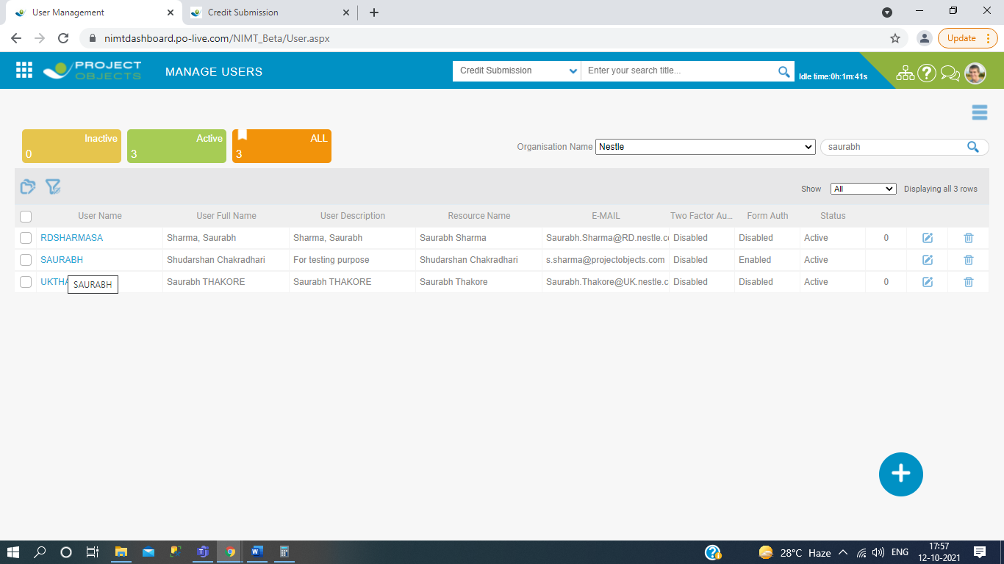

1. Then log off the current page and try to created user_id into the login page.

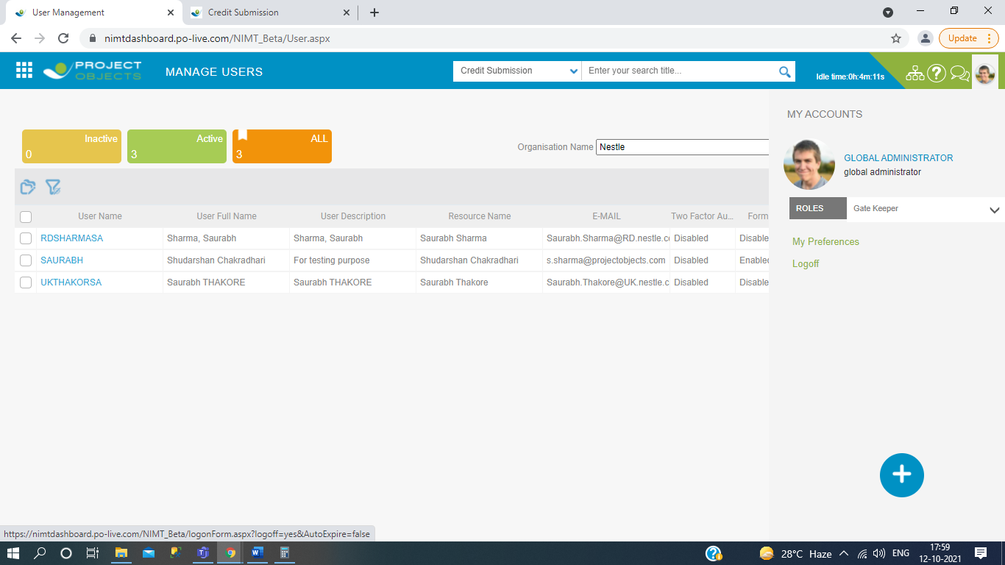

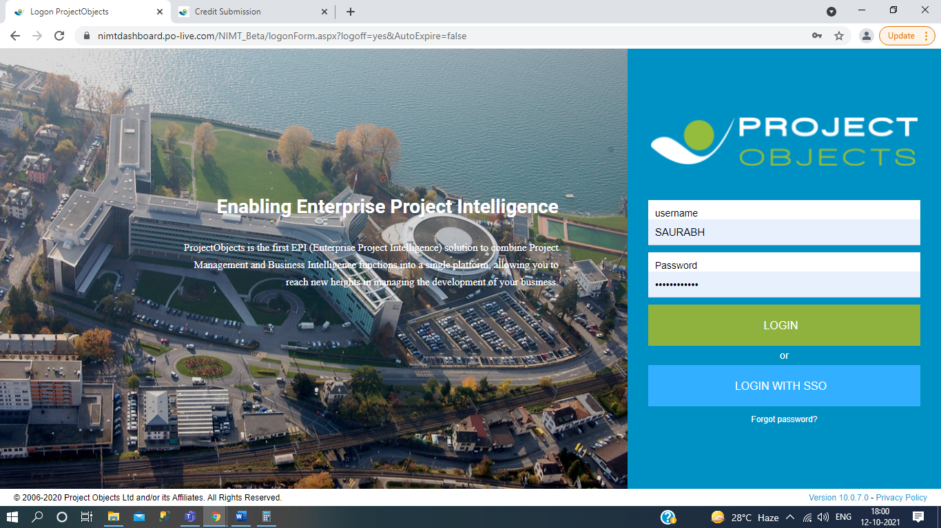

Now you can see the home page after using your user_id.

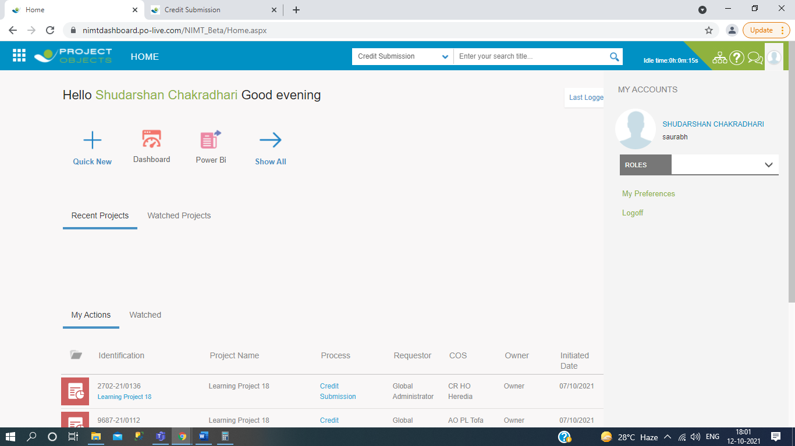

**Workflow of Group Management :**

1. Click on the Group icon in configuration.

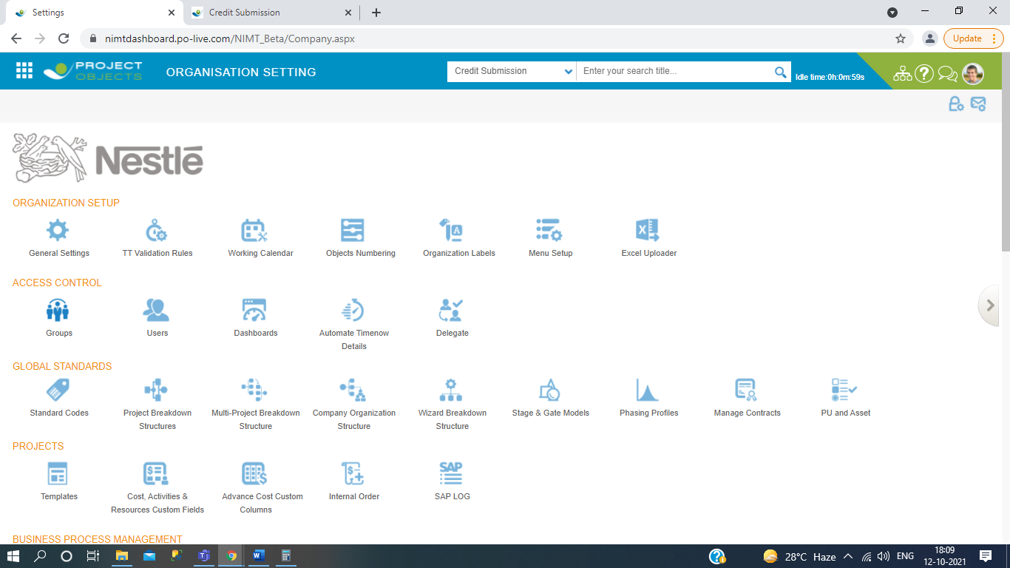

1. Click on create new.

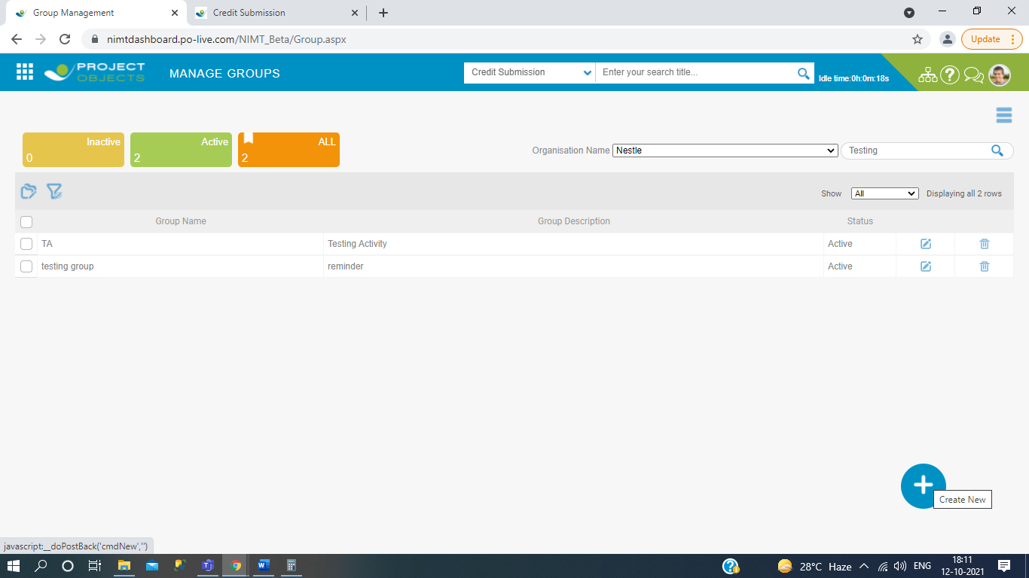

1. Then filled the general details.

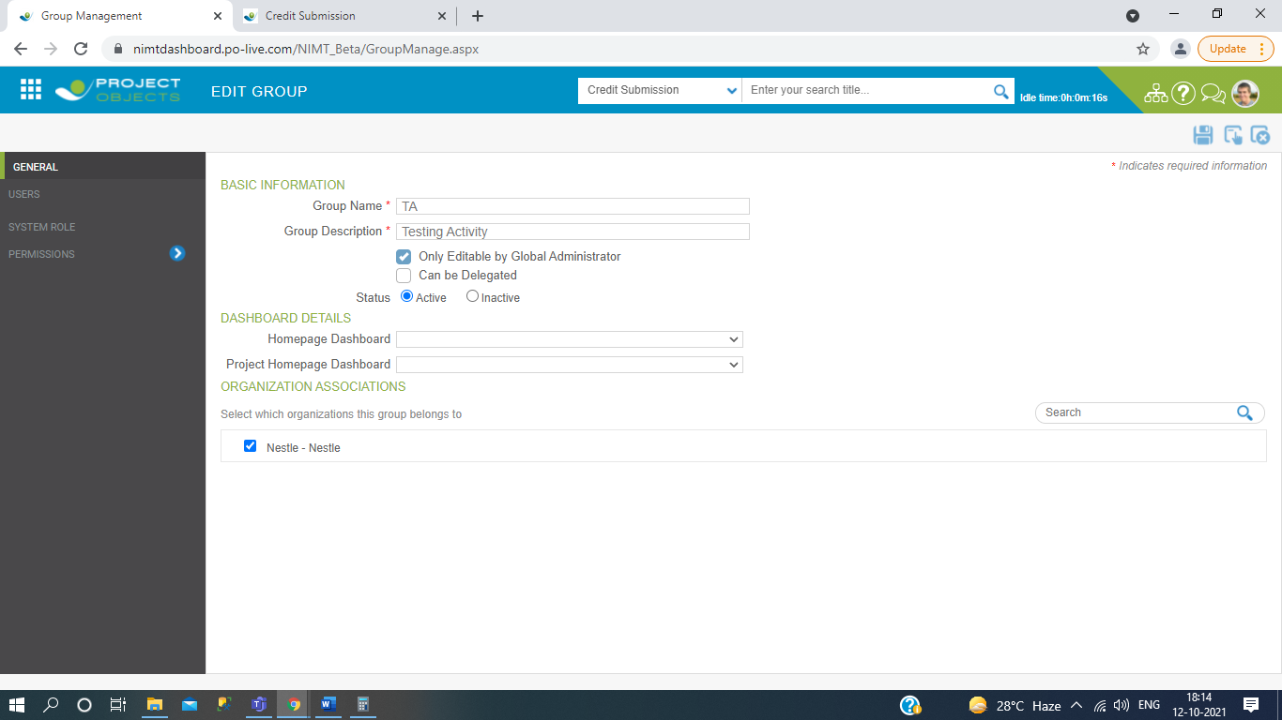

1. Then go to the user and search your user name which one you have to created in user management.

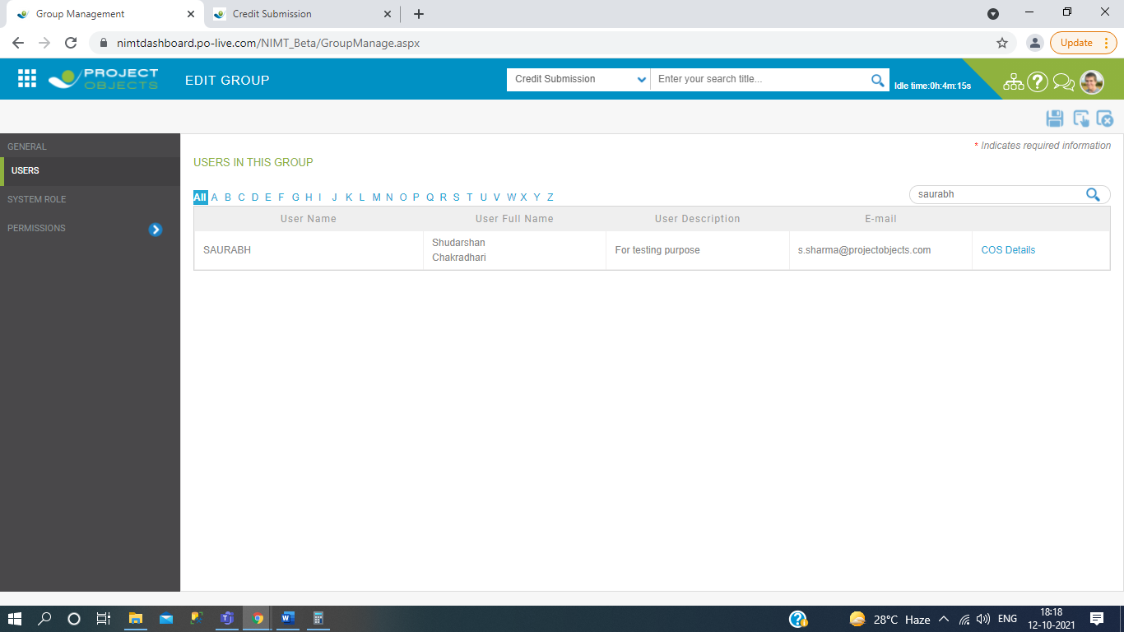

1. Then go to the system role and here we are select the role.

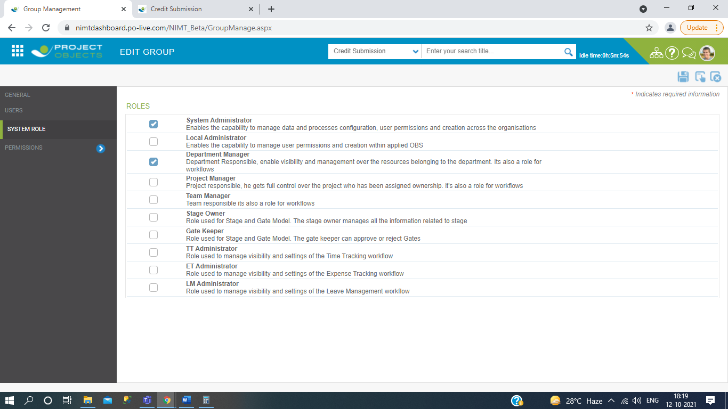

1. Then you click on permission, in this we set the multiple types of permissions, which is use in User management.

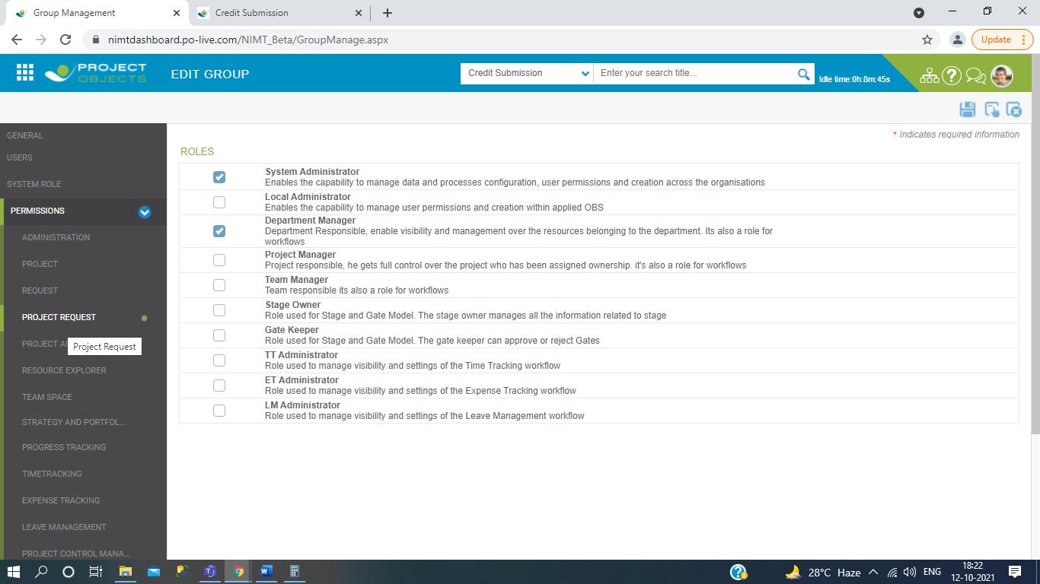

1. Then save it.

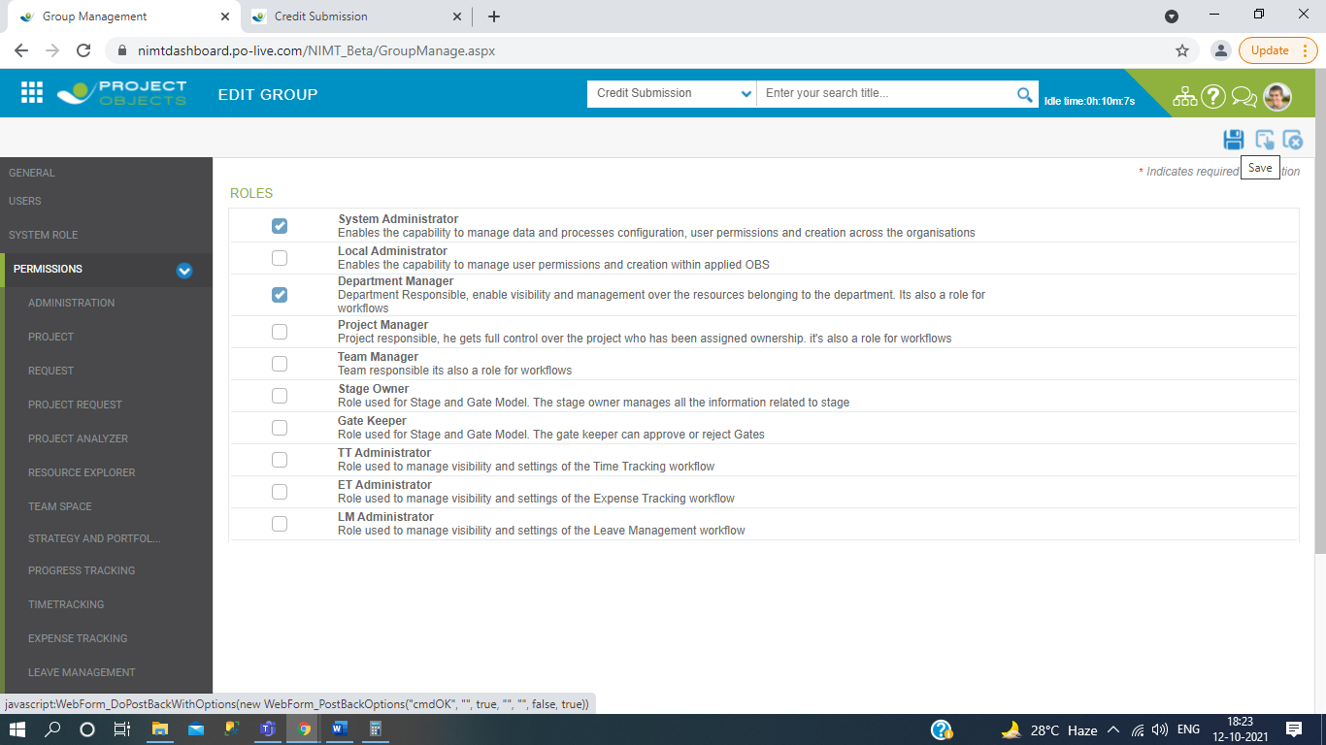

1. Now after creation of group it will be see in the User management at group selection.

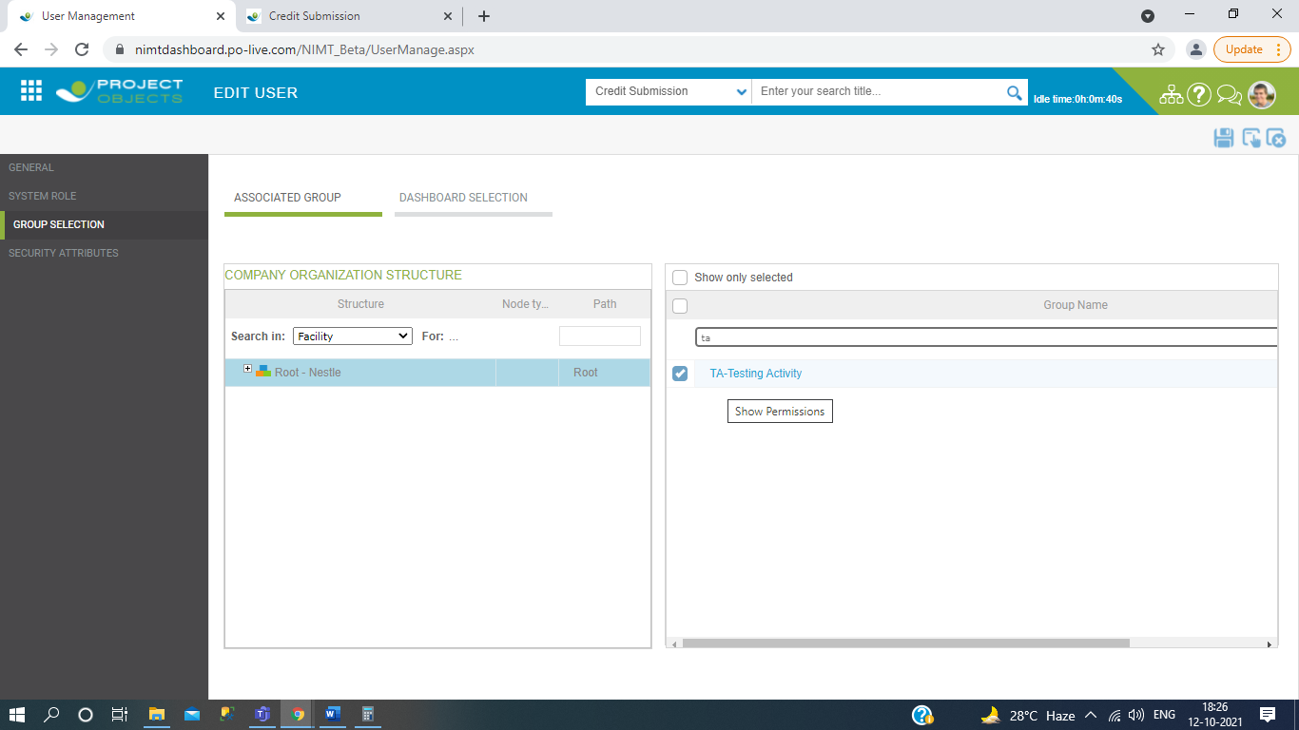

This is all about the User & Group Management.

# FUNCTIONALITIES OF Tab creation in credit summary.

1. Go to the menu and click on the credit submisson.

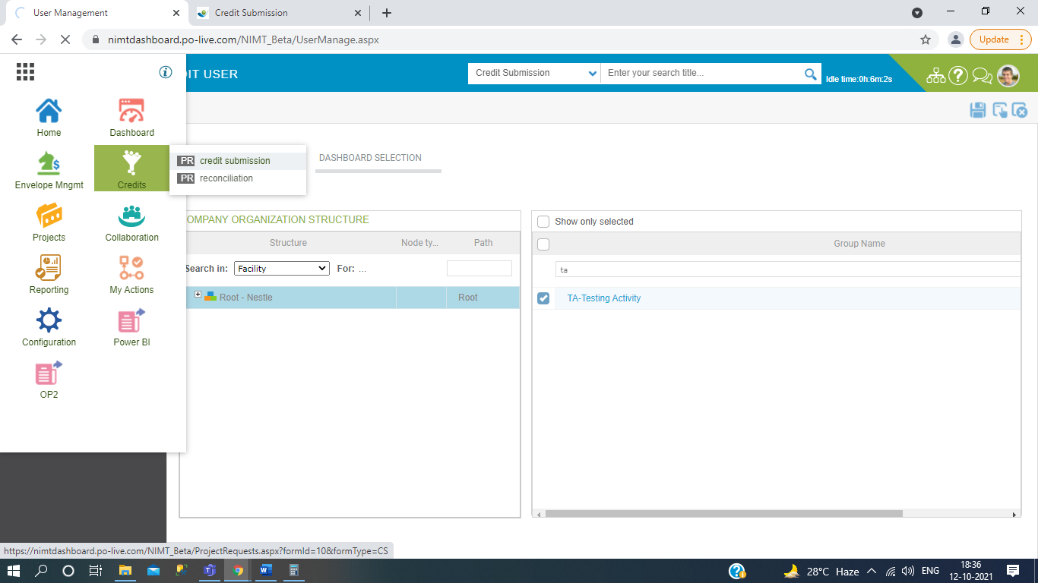

1. After open the credit register , click on more view then click on create search.

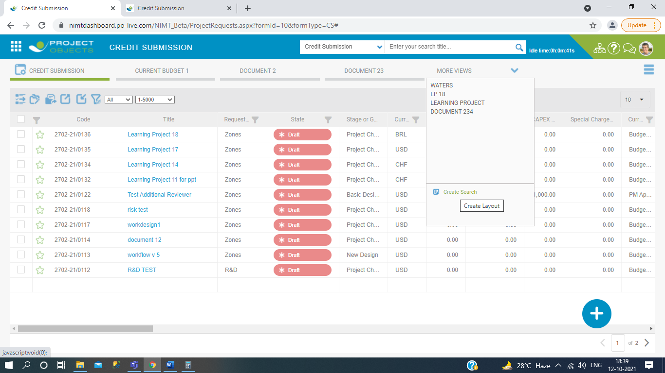

1. Filled the necessary fields.

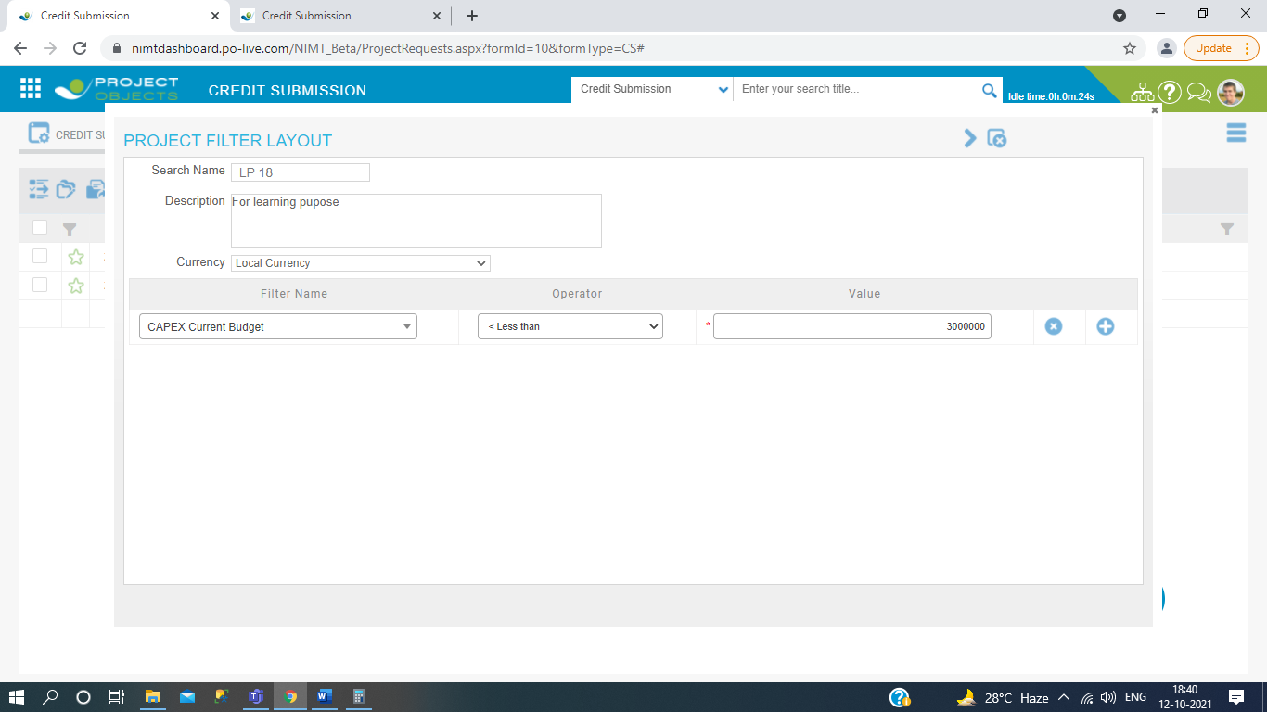

1. Select the multiple coloumns which one you want to show in the tab then save it.

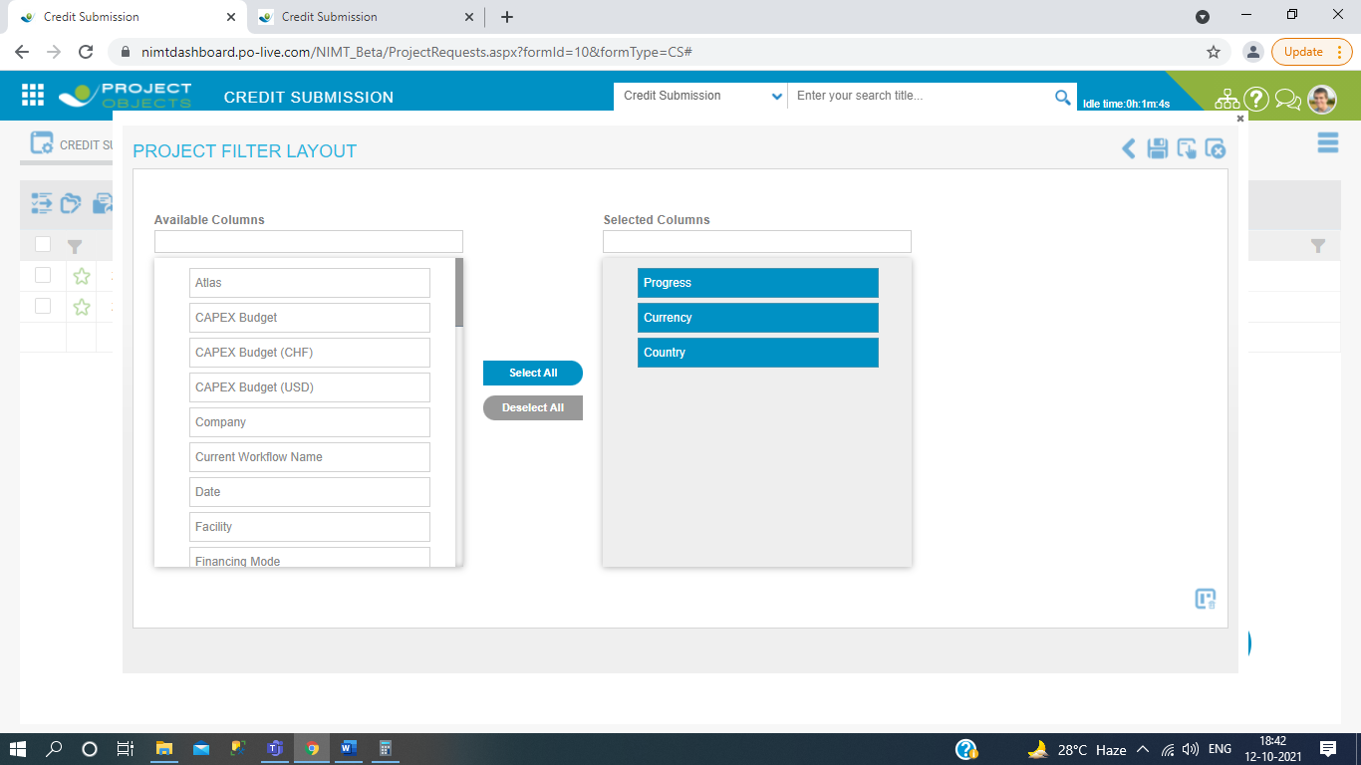

1. Now your tab is created after your given conditions in the filled and then data comes filtered into the tab in selected columns.

